**Press release**

**July 2025**

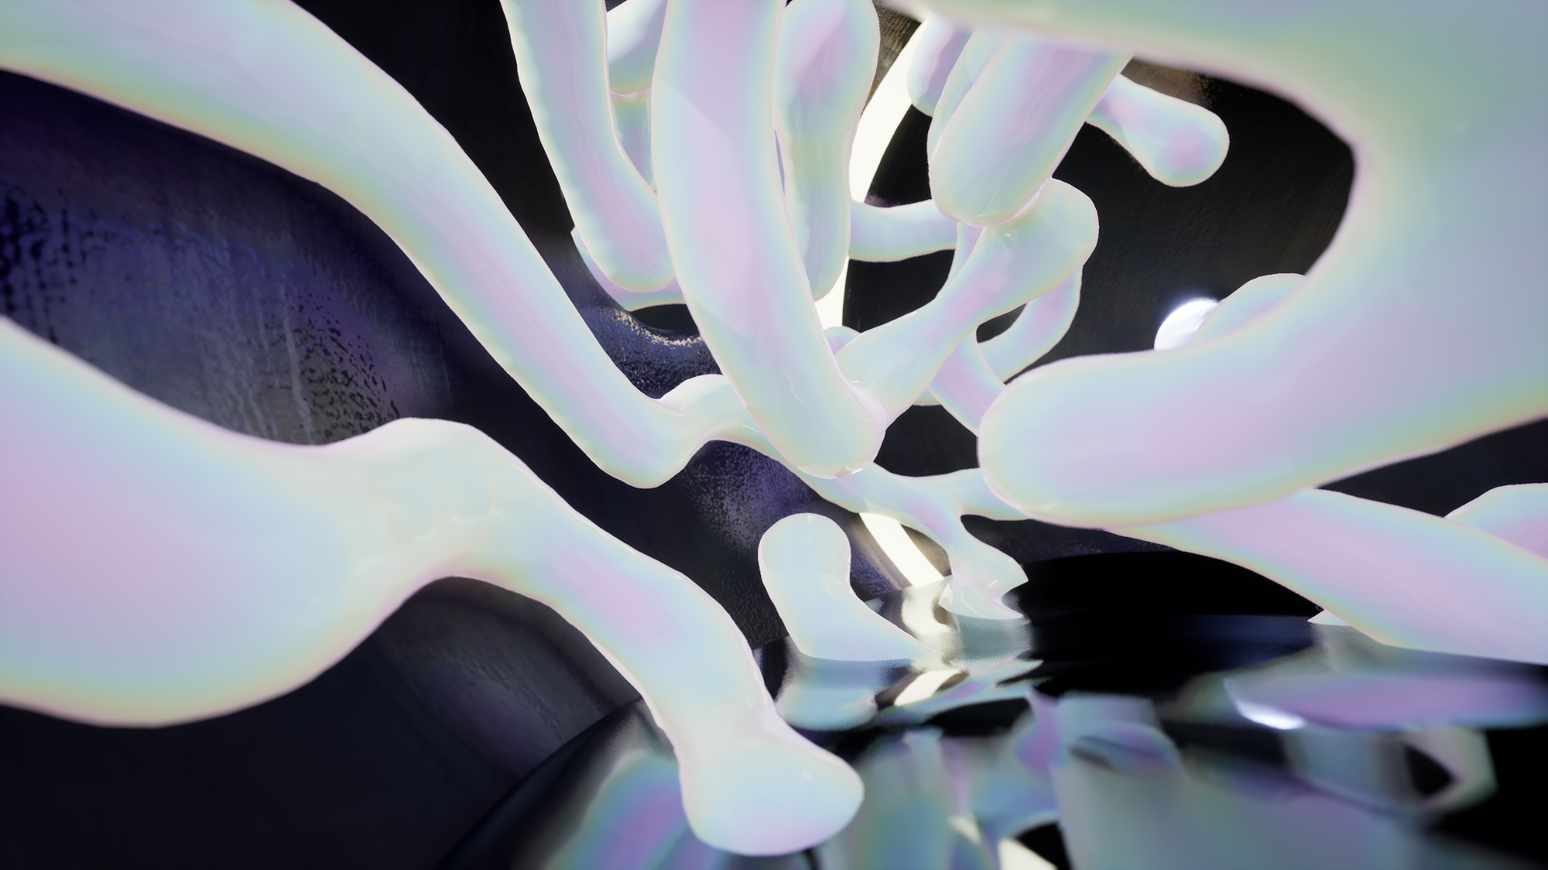

Gregory Herbert in collaboration with Professor Katie J. Field, *Making-with*, 2021. Film still.

**It Requires Getting Lost**

1 November 2025 – 22 February 2026

**Artists: Magdalena Abakanowicz, Noemie Goudal, Gregory Herbert, Pierre Huyghe, Malik Jama, Leon Kossoff, Jocelyn McGregor and Wolfgang Tillmans**

**It Requires Getting Lost** is the result of a unique partnership between the Roberts Institute of Art (RIA), Venture Arts and Castlefield Gallery. Three artists working in the North of England –– Gregory Herbert, Malik Jama and Jocelyn McGregor –– have been invited by the partner organisations to work in dialogue with one another and in response to major works from one of the UK’s most significant private collections, the David and Indrė Roberts Collection (managed by RIA). These major works, co-selected by all involved, will be featured in the exhibition.

Spending time with the collection commenced a research period designed to support Herbert, Jama and McGregor to develop new work for the exhibition at Castlefield Gallery. These new works will be exhibited alongside the works by **Magdalena Abakanowicz, Noemie Goudal, Pierre Huyghe, Leon Kossoff, and Wolfgang Tillmans** from the David and Indrė Roberts Collection. Sharing and exploring together has shaped Hebert, Jama and McGregor’s development process.

The artists have together experienced one another’s sources of inspiration, including places and spaces where humanity and nature come into contact in unexpected ways. To date these have included Anderson boat lift, a wishing well in Alderley Edge and Yordas Cave in Ingleton. Guiding the artists’ research and overall exhibition are shared interests in the complex entanglement of human and non-human worlds, and testing the boundaries between the natural and artificial, making and material, intention and accident.

Selected and commissioned works featured in **It Requires Getting Lost** will span film, photography, painting, sound, projection mapping, and sculpture. A diverse group of works, together they point to what can be discovered in embracing the unknown. The exhibition will ask if we can resist the drive to want to be all knowing and to have all the answers, and instead accept not knowing. What might we learn? If we ‘get lost’, might we discover, see, and hear anew, including what nature has to share with us?

**It Requires Getting Lost** will take over Castlefield Gallery, with the works and installation playing with the context of the venue’s architecture, creating a cave-like, subterranean feel. Conceived as a dark, underground space, the exhibition invites us to leave behind the hard-edged clarity of categories and distinctions and descend into a place of murky yet wondrous possibility.

The exhibition proposes that in the dark of not knowing we might actually find hope, and that with humility we can better respond to the challenges of our changing world. The exhibition’s title is taken from a phrase used by philosopher and activist Bayo Akomolafe from an interview the artists and partners read together during the project. It suggests that getting lost together can catalyse true transformation and deeper understanding of the many paths we can take to live more responsively and responsibly in a world that is continually changing.

The whole project has been infused with positivity and curiosity from the start, offering the artists an opportunity to visit outdoor locations from Hulme Community Garden Centre to Stonehenge as well as exploring some of the most significant works of art from the 20th and 21st centuries in the David and Indrė Roberts Collection. Their time together will lead to an exhibition that invites us to wonder amongst art works that encourage us to be at ease with the unknown and to embrace the unfamiliar offerings of our natural world.

**ENDS//**

**Related Public Programme Event:**

**Remember Nature 2025**

**4 November 2025**

Castlefield Gallery is taking part in Remember Nature 2025 with commissioned Lead Artist Yu-Chen Wang. Remember Nature 2025 marks the 10-year anniversary of the visionary art project initiated by artist Gustav Metzger (1926-2017).

Curated by Jo Joelson and Andrea Gregson, in partnership with 15 regional arts partners across England, Remember Nature will culminate in a Day-of-Action on 4 November 2025, bringing people together through a programme of cultural and artistic public interventions, to 'remember nature' and act collectively to face the climate and nature crisis.

This Day-of-Action will take place in Platt Fields Park, Fallowfield. Aimed at local people and put on by six local artists convened by Phil Barton, a series of walks and workshops will take place during the day, including one from Platt Hall to Hulme Community Garden Centre and back again.

[remembernature.art](https://www.remembernature.art/)

**Notes to Editors:**

**Images available** [**here**](https://drive.google.com/drive/folders/1AT38JScqa-NgdceErQd-DgIGxhRDmsUQ?usp=sharing)

**More information about the exhibition’s artists and partners** [**here**](https://docs.google.com/document/d/18d21G_2iDYhZjjX8c9sqbBN3Zg0rer2jMVgm3LBv_7w/edit?usp=sharing)

**For further information and images, or to arrange interviews, please email Leslie Remonato at** [**leslie@castlefieldgallery.co.uk**](mailto:press@castlefieldgallery.co.uk)

**Exhibition Title:** It Requires Getting Lost

**Exhibition dates:** Sunday 1 November 2025 – Sunday 22 February 2026

**Preview:** Thursday 30 October 2025

**Slow Saturday Preview:** Saturday 1 October 2025

**Venue:** Castlefield Gallery, 2 Hewitt Street, Manchester M15 4GB

**Tel:** 0161 832 8034

**Web:** castlefieldgallery.co.uk

**Email:** info@castlefieldgallery.co.uk

**Opening Times:** Wednesday – Sunday, 12 noon – 5:30 pm

**It Requires Getting Lost** is commissioned and produced by Castlefield Gallery, the Roberts Institute of Art and Venture Arts, with additional support from the Brian Mercer Trust and The Haworth Trust. Castlefield Gallery and Venture Arts are generously funded by Arts Council England and Manchester City Council.

**Partners:**

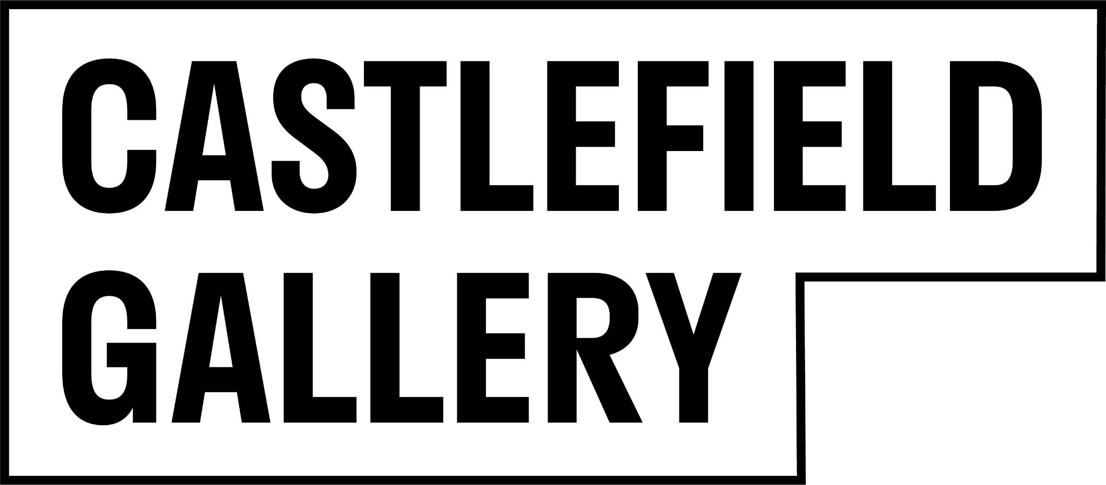  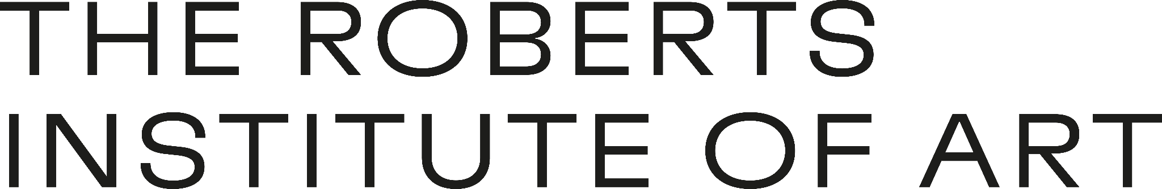

**Funders:**

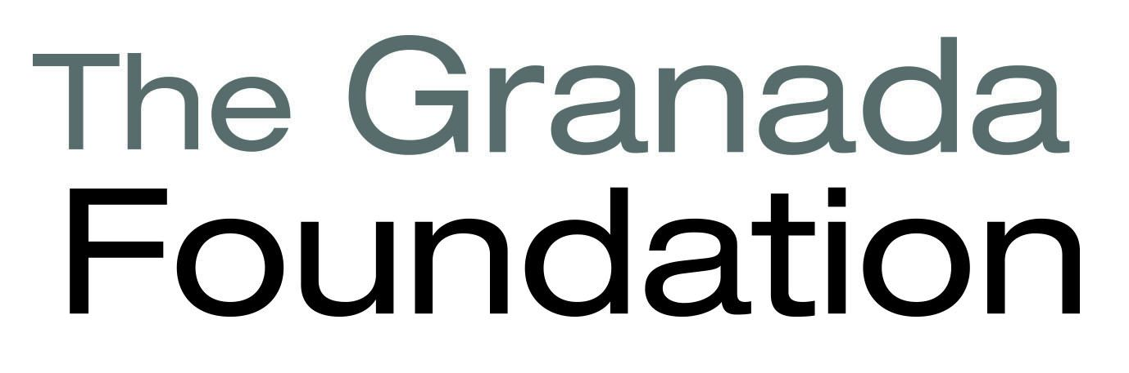

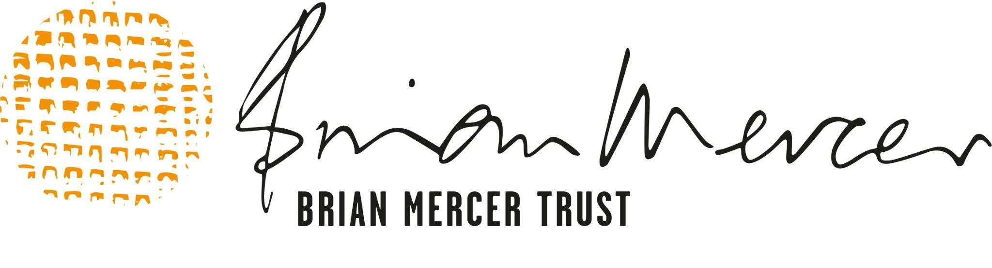 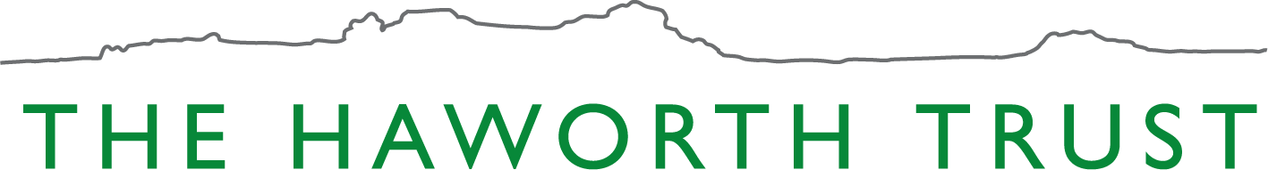

**Partner funders:**

