**Press release**

**May 2025**

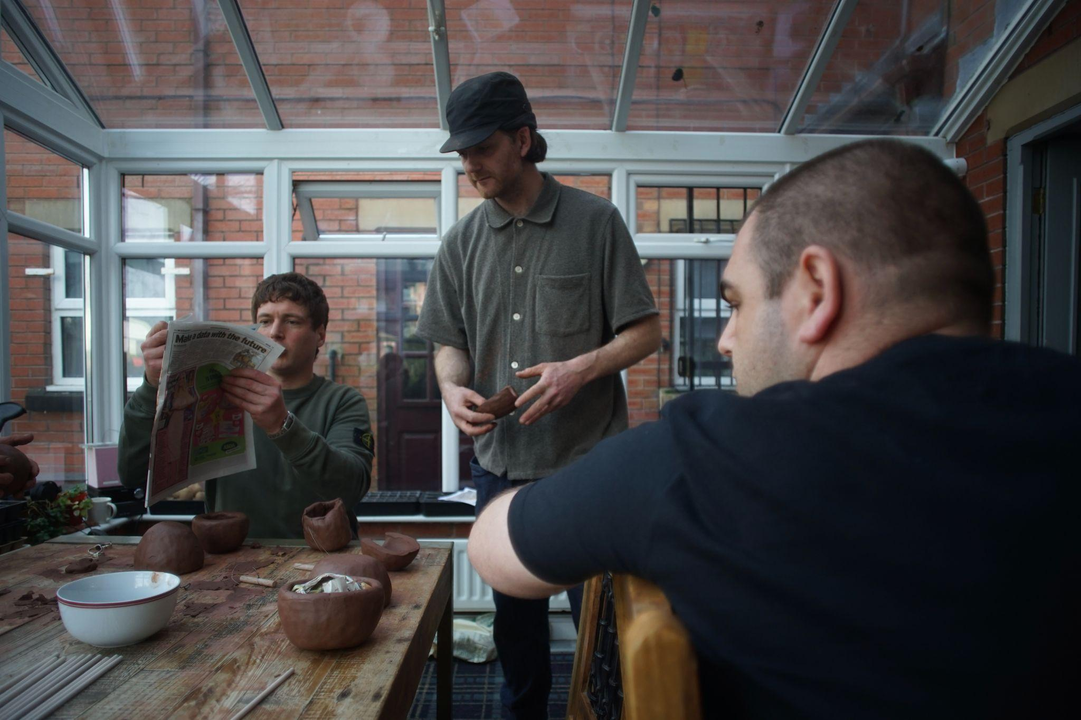

Teapots, ANEW Way to Peel an Orange, 2025. Image courtesy of Joe Hartley

**ANEW Way to Peel an Orange**

*A co-created exhibition of new work developed by Joe Hartley and the ANEW recovery community*

3 August – 19 October 2025

Celebrated designer Joe Hartley and the ANEW recovery community present **ANEW Way to Peel an Orange***,* an ambitious exhibition of co-produced work developed during Hartley’s five-month residency with ANEW in Tameside (Greater Manchester, UK).

Hartley’s residency has combined the forces of ANEW’s experienced and creative approach to recovery from substance use, with Hartley's diverse approach to making and the variety of talents possessed by members of the ANEW community. Rooted in collaboration and creative exchange, the residency has been an evolving journey of creating and reflecting through ceramics and furniture making, photographic experimentation, as well as outdoor and growing activities that include equine-assisted therapy and hatching RECOVERIST chickens as a nurturing metaphor for new life beginnings.

Over the course of Hartley’s time with ANEW, the designer and community have immersed themselves in one another’s spaces and practices. Saturated with a generosity of spirit, honesty, and care, their time together has fostered a deep relationship, feeding a meaningful process of creatively working together to craft new contemporary artworks that challenge thinking around substance use and what it means to be in recovery.

The resulting exhibition will draw together a dynamic collection of artworks - from large-scale black-and-white photographs to ceramics and site-specific interventions that harness the techniques, energy, and immediacy of graffiti - this speaking to the positive energy Hartley and all at ANEW bring to their co-production. Commissioned works are informed by lived experience and underpinned by the critical importance of recovery as a collective process. The presentation itself is to be co-produced with Hartley and ANEW, including the display stands, exhibition furniture, and framing.

Castlefield Gallery will also play host to Hartley and ANEW’s pop-up shop, a space that will imbue the warmth of a rustic farm shop. The shop will house teapots and ceramics enhanced with glazes produced from plants - those often viewed as invasive and not welcome, that when repurposed yield positive, unexpected results. Interventions will appear outside the gallery’s immediate public realm. Hartley and the ANEW community will bring their collaboratively honed growing skills to the venue by developing a garden at the gallery’s entrance occupied by plants that include those used to produce the beautiful glazes to be found on the ceramics inside. The pop-up shop and garden will create further space for pause and reflection.

The title of the exhibition is associated with the phrase ‘Peeling an orange in your pocket’ - a saying that can have multiple meanings, including alluding to secrecy, but more relevant here is the idea of layers and hidden talents, as well as peeling an orange for someone being an act of love and devotion. The exhibition will ask, *‘is there not more than one way of looking at things?’* Shaped by lived experience, underpinned by the importance of process to journeys of recovery for personal growth and healing, the exhibition will seek to prompt and invite conversation over proposing definitive answers.

**Quotes**

“*We are learning that art and recovery can dovetail together to create a relational experience that offers authentic connections, builds trust, and helps us to see each other’s joy and creativity one teapot at a time*.” ANEW recovery community

“***ANEW Way to Peel an Orange*** *is about creating a culture of encouragement.*”Joe Hartley, designer

**Exhibition public programme**

**CHAORDIC National Symposium**

Thursday 25 September 2025

Delivered by [**Portraits of Recovery**](https://portraitsofrecovery.org.uk/), the **CHAORDIC National Symposium** will be a landmark, one-day sharing event, with key insights examining the transformative power and pivotal role of the arts in driving social and cultural change on substance use recovery. The event will take place at the Whitworth and Castlefield Gallery. [**CHAORDIC press release**](https://docs.google.com/document/d/1ySy9ixXmbdZCKSJyLV7PU58nJvhA13MX/edit?usp=sharing&ouid=109568435375570597753&rtpof=true&sd=true)

**A New Way to Peel an Orange**forms part of the pioneering 3-year commissioning programme [**CHAORDIC**](https://portraitsofrecovery.org.uk/project/chaordic/), initiated and led by [**Portraits of Recovery**](https://portraitsofrecovery.org.uk/about/), developed and delivered in partnership with Castlefield Gallery, the Whitworth and Manchester Art Gallery.

**CHAORDIC** explores the social impact that collaborative contemporary visual arts can play in redefining substance use narratives and recovery identities. The **CHAORDIC National Symposium** and **A New Way to Peel an Orange** are key events for **Portraits of Recovery’s** [**RECOVERIST Month**](https://portraitsofrecovery.org.uk/project/recoverist-month-2024/) **(September 2025)** - placing lived experience at the heart of an annual, month-long arts programme.

**RECOVERIST = recovery + activist**

Further exhibition and public programme events for **A New Way to Peel an Orange** are to be announced.

**ENDS//**

**Notes to Editors:**

**Images available** [**here**](https://drive.google.com/drive/folders/1mgNz5AMzmrravBePwACCl--FgTv2zRrz?usp=drive_link)

**More information about the exhibition’s artist and partners** [**here**](https://docs.google.com/document/d/1F8wauhlRLRpRkmo8w7DrEI_MppaMEnLhqRCtP0aurko/edit?usp=sharing)

**For further information and images, or to arrange interviews, please email Leslie Remonato at** [**leslie@castlefieldgallery.co.uk**](mailto:press@castlefieldgallery.co.uk)

**Exhibition Title:** ANEW Way to Peel an Orange

**Exhibition dates:** Sunday 3 August – Sunday 19 October 2025

**Preview:** Thursday 31 July 2025

**Slow Saturday Preview:** Saturday 2 August 2025

**Venue:** Castlefield Gallery, 2 Hewitt Street, Manchester M15 4GB

**Tel:** 0161 832 8034

**Web:** castlefieldgallery.co.uk

**Email:** info@castlefieldgallery.co.uk

**Opening Times:** Wednesday – Sunday, 12 noon – 5:30 pm

**ANEW Way to Peel an Orange**is a Portraits of Recovery and Castlefield Gallery commission, developed and presented in partnership with ANEW, funded by Brian Mercer Trust, The Howarth Trust, supported by Arts Council England, the Greater Manchester Combined Authority and Manchester City Council.

**ANEW Way to Peel an Orange*,* Partners:**

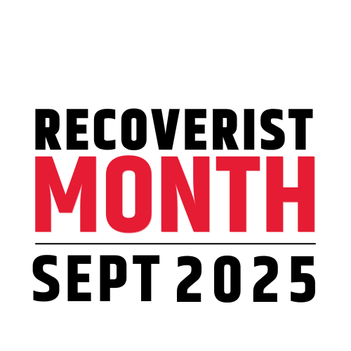 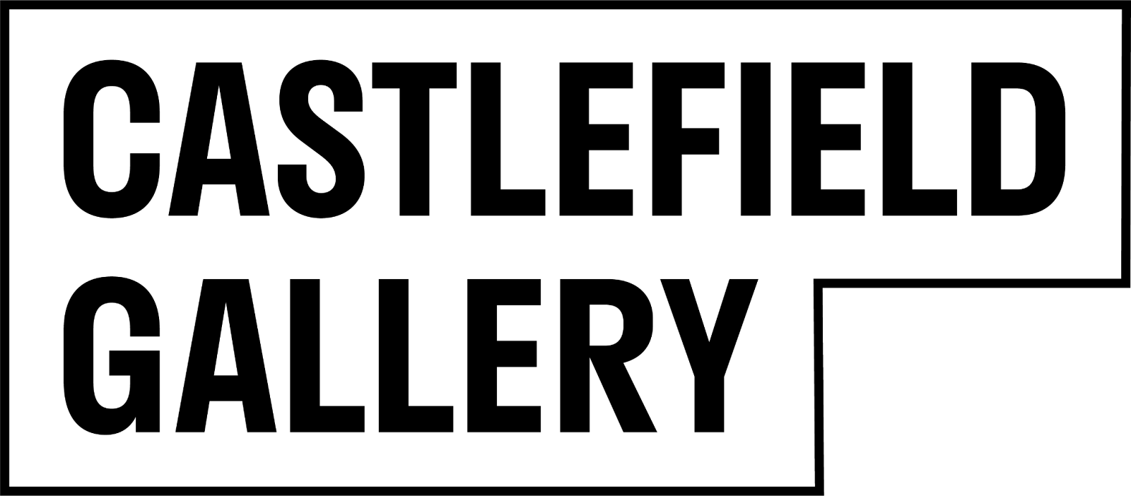

**ANEW Way to Peel an Orange,Funders:**

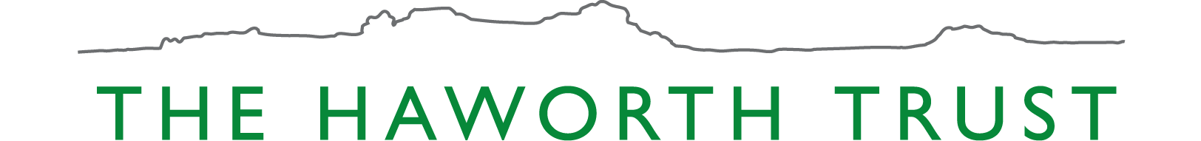

**Partner funders:**

 