**Press release**

**May 2025**

**CHAORDIC (managed chaos)**

***New Radical Art Commissions Disrupting Narratives on Substance Use and Recovery***

**CHAORDIC National Symposium**

**Led by Portraits of Recovery, with partners the Whitworth, Castlefield Gallery and Manchester Art Gallery.**

A pioneering 3-year commissioning programme [**CHAORDIC**](https://portraitsofrecovery.org.uk/project/chaordic/), initiated by [**Portraits of Recovery**](https://portraitsofrecovery.org.uk/about/) (Manchester, UK), explores the social impact that collaborative contemporary visual arts can play on redefining substance use narratives and recovery identities.

Rooted in the concept of ‘[**RECOVERISM**](https://portraitsofrecovery.org.uk/about/manifesto/)**’** - a dynamic social art movement conceived by Portraits of Recovery - CHAORDICchampions cultural visibility, citizenship, and transformative programming that reflects the needs of Greater Manchester’s recovery communities. Through creative journeying, CHAORDIC empowers individuals to reimagine and re-shape their world, to become ‘**Recoverists’ (Recoverist = Recovery + Activist)**, and drive lasting social change.

**Groundbreaking CHAORDIC exhibitions launching July and August 2025**

**RECOVERIST CURATORS**

*An exhibition curated by people in recovery from substance use, which re-narrates artworks from the Whitworth collection through a Recoverist Lens*

**The Whitworth**

**Friday 25 July – June 2026**

**(Preview 24 July)**

Driven by lived experience of substance use and recovery, the Recoverist Curators collaboration is an activist based process, developing inclusive ways for working with people and communities in recovery. The **Recoverist Curators** exhibition has led to the development of new knowledge, and increased cultural confidence for successful creative Recoverist engagement.

Recovery is often misunderstood. Recovery is not finite; it is a social process, a

journey. It is cultural, contemporary and in the moment. Through the lens of recovery the curators have researched and reinterpreted the Whitworth’s collection. By curating this exhibition of artworks and engaging the public, the Recoverist Curators share their inspirational stories of hope, fear, desires and dreams.

**Recoverist Curators**supports Portraits of Recovery and the Whitworth’s collective mission for art as a means for positive social change, increased mental health and well-being and for shifting balances of power to a more equitable approach. Recoverism as an inclusive ideology to support society to better look at itself as a whole and to shift how we think, work, live and express ourselves.

**ANEW Way to Peel an Orange**

*A co-created exhibition of new work developed by Joe Hartley and the ANEW recovery community*

**Castlefield Gallery**

**Sun 3 August – Sun 19 October 2025**

**(Preview 31 July 2025)**

"*We are learning that art and recovery can dovetail together to create a relational experience that offers authentic connections, builds trust, and helps us to see each other’s joy and creativity one teapot at a time*." (ANEW recovery community)

Selected by ANEW as their artist in residence, celebrated designer Joe Hartley and the ANEW recovery community present **ANEW Way to Peel an Orange**.

Over the course of Hartley’s residency, he and ANEW have immersed themselves in one another’s spaces and practices. The project has brought together ANEW’s experienced and creative approach to recovery and Hartley's diverse approach to making, with the talents possessed by members of the ANEW community. Saturated with a generosity of spirit, honesty, and care, their time together has fostered a deep relationship, feeding a meaningful process of creatively working together to craft new contemporary artworks that challenge thinking around substance use and what it means to be in recovery.

Rooted in collaboration and creative exchange, the residency has been an evolving journey of making, reflecting, and connecting through ceramic, photographic, growing, and other outdoor activities, including equine-assisted therapy.

Shaped by lived experience, and underpinned by the importance of process to journeys of recovery for personal growth and healing, the exhibition will invite conversation and be further co-developed with Hartley and ANEW, including the show’s exhibition furniture and frames. The exhibition will bring together a powerful collection of co-produced ceramics and large-scale photographic works. Castlefield Gallery’s upper space will house a pop-up shop with items made by Hartley and ANEW, free refreshments, and space to pause and reflect. Further interventions may also see work appearing outside the gallery space, with the **ANEW Way to Peel an Orange**’spublic programme extending the exhibition’s call to action to get behind the recoverist movement!

**CHAORDIC 2023-24**

**Let’s Talk about Chemsex, led by Harold Offeh**

**Commissioned by Portraits of Recovery, with partners Manchester Art Gallery and Brighter Sound**

[**Let’s Talk about Chemsex**](https://portraitsofrecovery.org.uk/project/lets-talk-about-chemsex/)was a year-long project throughout 2023-24. Led by artist Harold Offeh, the project aimed to explore the queer communities’ broad range of experiences of sex on Chems. Harnessing the power of the legendary Salt N Pepa track *Let's Talk About Sex (1991)*, at the height of the AIDS crisis, the track aimed to de-stigmatise the discussion of sex and desire in popular culture.

Using workshops, talks, and performance, Offeh’s and his collaborators explored consent, intimacy, and desire, visually mapping and surveying a diverse range of experiences amongst people based in Manchester. It culminated in a [**takeover at Manchester Art Gallery**](https://portraitsofrecovery.org.uk/whats-on/lets-talk-about-chemsex-manchester-art-gallery-takeover/) with a day of performance by international artists and a co-produced 12-inch double A-side single [**limited-edition vinyl**](https://haroldoffeh.bandcamp.com/album/lets-talk-about-chemsex-presents) **record**.

**Let's Talk About Chemsex** drew on the history and efforts by organisations in Manchester to promote non-judgemental discussions on Chemsex, consent, HIV and queer intimacy. Find out more about the project, including further collaboration with artists Jak Skot and Niall O’Conghaile aka ‘The Niallist,’ [**here**](https://manchesterartgallery.org/lets-talk-about-chemsex/).

**CHAORDIC National Symposium**

**Thursday 25 September 2025**

**Portraits of Recovery & the Whitworth, followed by a closing event at Castlefield Gallery**

A landmark, one-day sharing event, with key insights examining the transformative power and pivotal role of the arts in driving social and cultural change on substance use recovery. Further details to be announced. **A Recoverist Month Sept 2025** event with funding from the Baring Foundation.

**RECOVERIST CURATORS** and **ANEW Way to Peel an Orange**are also presented as part of [**Recoverist Month**](https://portraitsofrecovery.org.uk/project/recoverist-month-2024/)**, Sept 2025** - placing lived experience at the heart of a month-long arts programme.

**ENDS//**

**Recoverist Month (Sept 2025)**

Each September, Portraits of Recovery presents [**Recoverist Month**](https://portraitsofrecovery.org.uk/project/recoverist-month-2024/), placing lived experience at the heart of a month-long arts programme. Through exhibitions, performances, screenings, and events, it offers audiences an authentic window into the world of recovery. By promoting positive community visibility, Recoverist Month reframes recovery from substance use as a viable lifestyle choice.

**Notes to Editors:**

**Images available** [**here**](https://drive.google.com/drive/folders/1MtvWhlUpeRh_E1wXS2e0VY4-40iDXu7s?usp=sharing)

**More information about CHAORDIC artists and partners** [**here**](https://docs.google.com/document/d/1ehJgfDFHYWg78G4zu9Y9eZViqNTn8W7iQ5QW6PBjGvA/edit?usp=sharing)

**For further information and images, or to arrange interviews, please email Leslie Remonato at** [**press@castlefieldgallery.co.uk**](mailto:press@castlefieldgallery.co.uk)

**Exhibition and symposium locations:**

**The Whitworth**

**Exhibition:** Friday 25 July - June 2026

**Preview:** Thursday 24 July

**Castlefield Gallery**

**Exhibition:** Sunday 3 August – 19 October 2025

**Preview:** Thursday 31 July 2025

**Slow Saturday Preview:** Saturday 2 August 2025

**Venue information:**

**The Whitworth**

The Whitworth, University of Manchester, Oxford Road, Manchester, M15 6ER

**Tel: 0161 2757450**

**Web:** whitworth.manchester.ac.uk

**Email:** whitworth@manchester.ac.uk

**Opening Times:** Tues to Sun 10 am – 5 pm, and Thursdays until 9 pm

**Castlefield Gallery**

Castlefield Gallery, 2 Hewitt Street, Manchester M15 4GB

**Tel:** 0161 832 8034

**Web:** castlefieldgallery.co.uk

**Email:** info@castlefieldgallery.co.uk

**Opening Times:** Wed to Sun 12 noon – 5:30 pm

**CHAORDIC partners:**

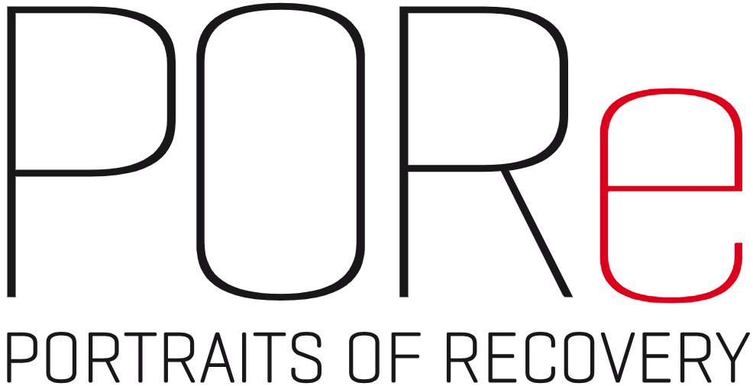 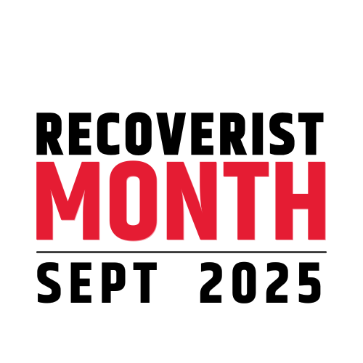  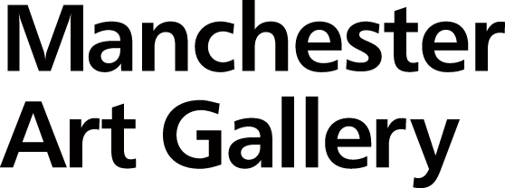 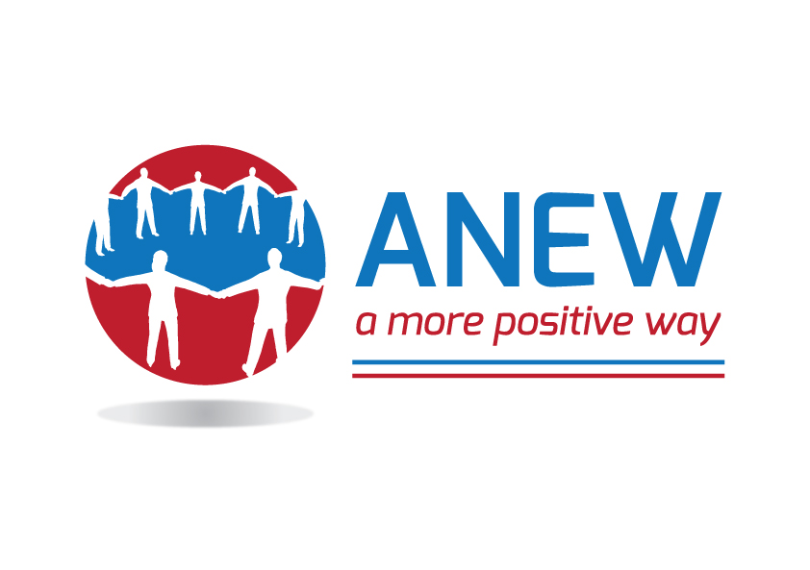

**

**CHAORDIC programme and project supporters:**

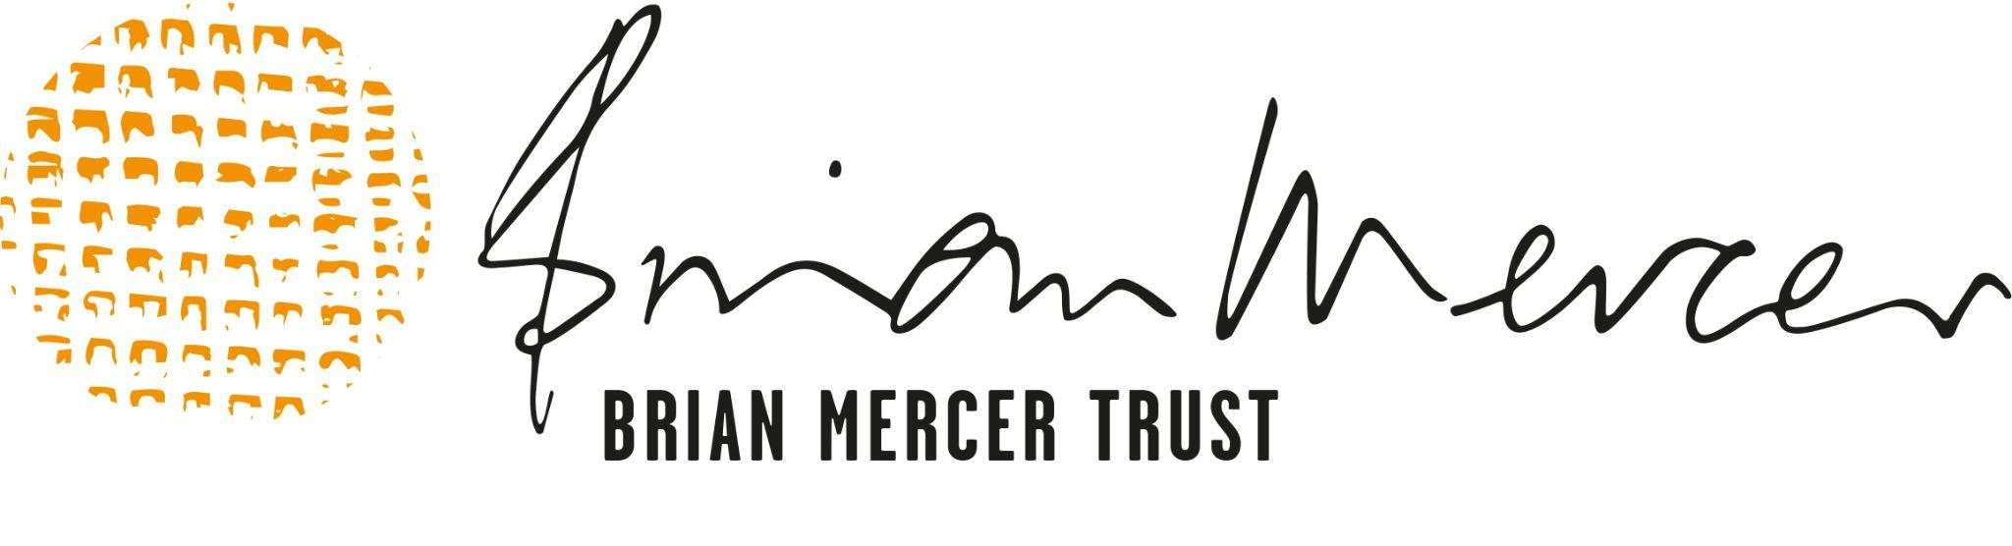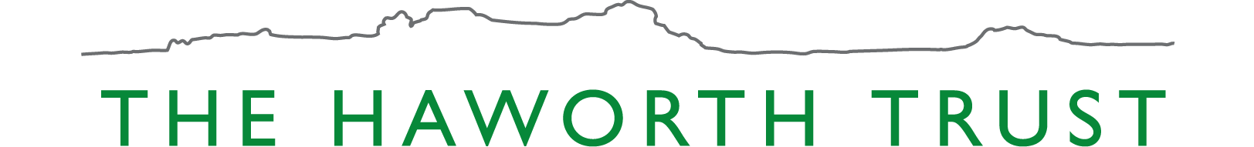

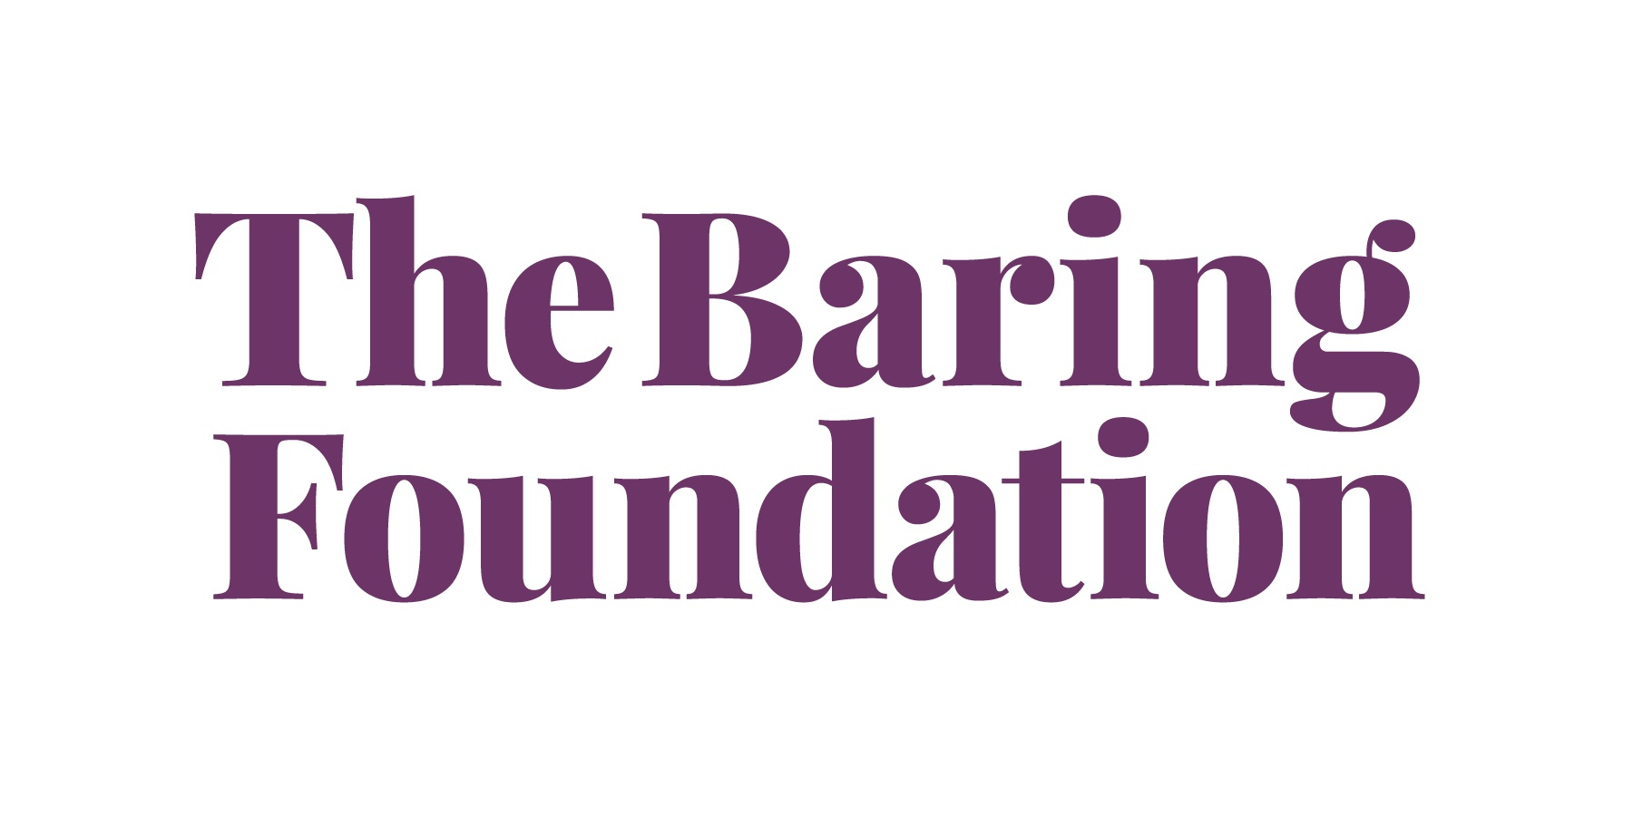

**Partner Supporters:**

