

**Press release**

**February 2025**

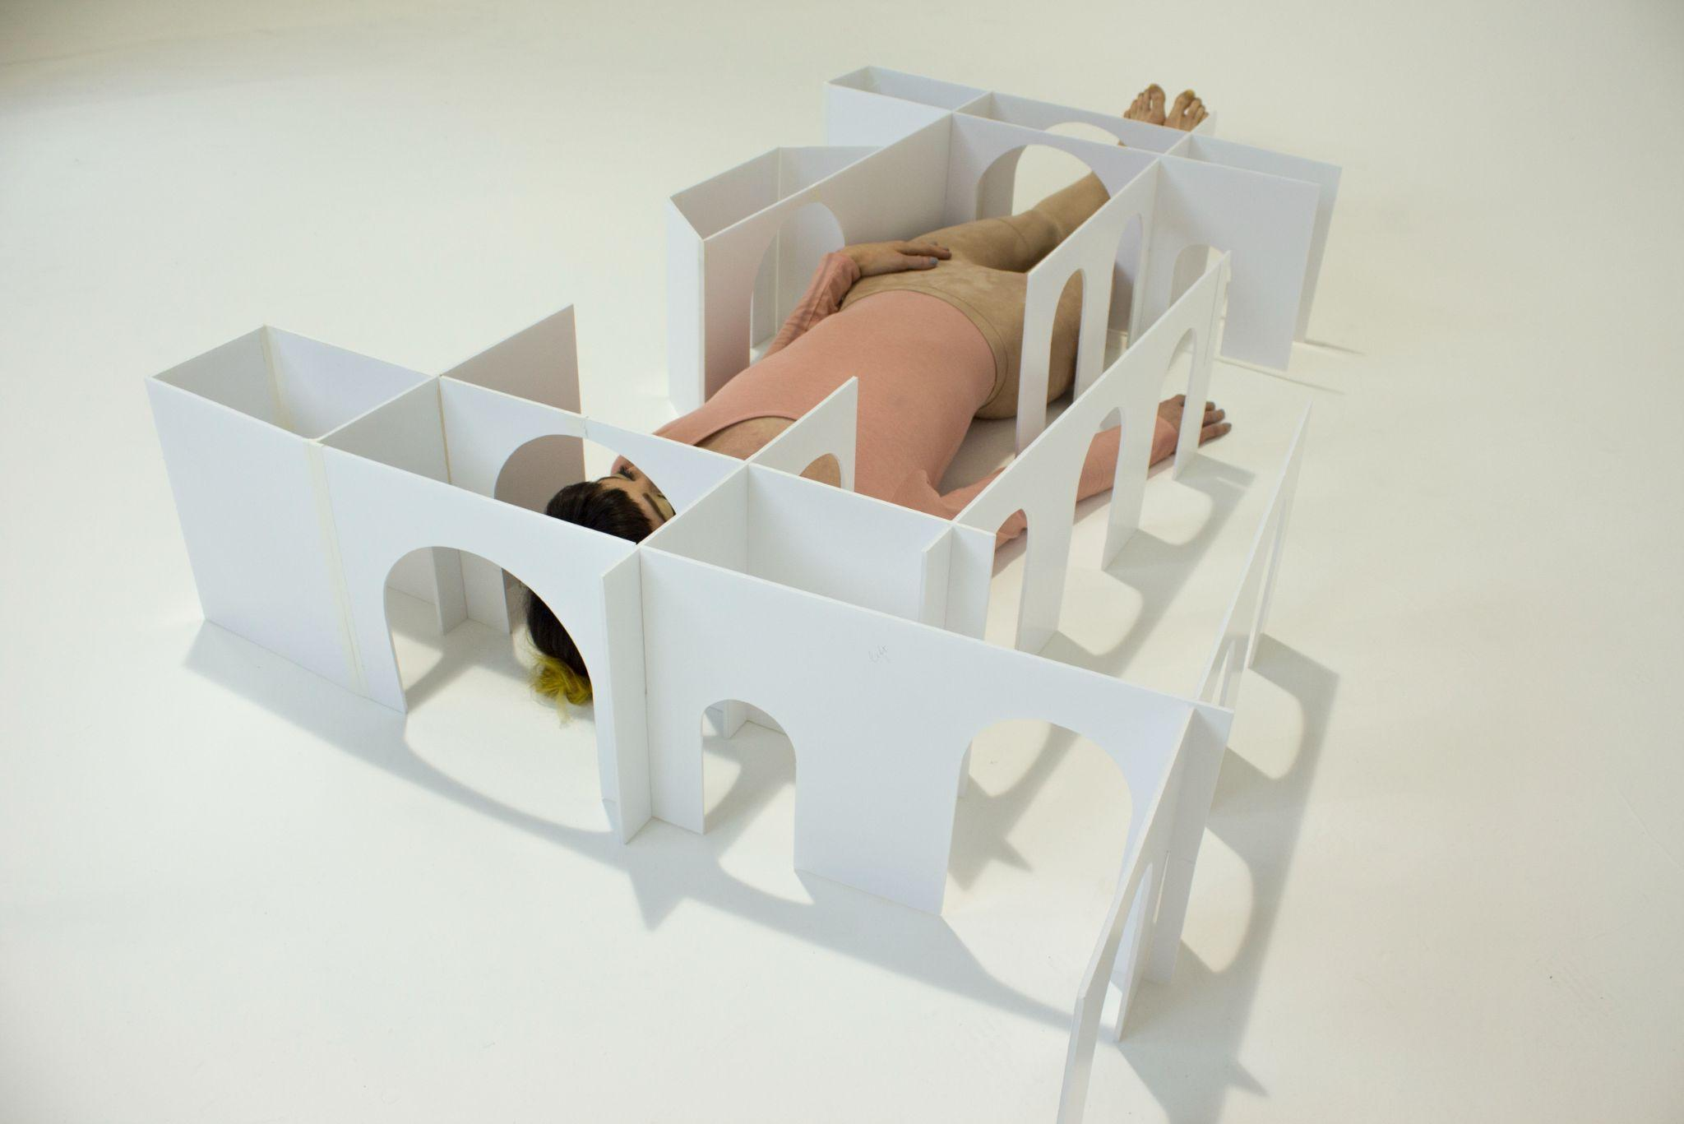

Emily Speed, *Rooms Designed for a Woman (film still),* 2017, commissioned by Yorkshire Sculpture Park.

**Energy House 2.0: Mishka Henner and Emily Speed**

4 May – 20 July 2025

This Spring Castlefield Gallery will launch an ambitious exhibition of new work by artists Mishka Henner and Emily Speed, in partnership with the University of Salford Art Collection, Open Eye Gallery and Energy House Labs. The exhibition will be the culmination of 18-month Artist Residencies with Energy House 2.0 at the University of Salford, a period in which the artists have immersed themselves in this world-leading energy performance facility, its cutting-edge research, and the facilities and research of the wider university.

A unique facility, Energy House delivers pioneering research on how carbon neutral and net zero homes, the homes of the future, will be built. Energy House 2.0’s chamber can accommodate two full-sized detached houses and simulate climatic conditions including wind, rain, snow, solar radiation and extreme temperatures. Research at Energy House cuts across science and technology, architecture, design and our rapidly changing climate; the artists’ residencies have taken Henner and Speed on different yet intersecting journeys.

At Castlefield Gallery, Henner will present a sound and video installation, which responds to data from the [Blitzortung](https://www.blitzortung.org/en/live_lightning_maps.php) network of over 10,000 lightning sensors positioned across six continents. Each time a lightning strike occurs somewhere in the world it will be recorded on a graphic musical score developed by Henner, which in turn triggers the sounds of percussion instruments. The work will create unique sonic events in the gallery which connect listeners' bodies to live data recorded on a planetary scale.

This piece by Henner is comparable to the day-to-day activity at Energy House 2.0 where scientists and researchers collect data from countless sensors and devices located in and around the houses built inside the facility’s chambers. That data provides information about the houses, the materials they are made from and how they react to various atmospheric conditions.

During his residency, Henner felt the spectre of the climate catastrophe haunted the facility. His work in some sense turns the kind of activity carried out at Energy House 2.0 inside out, putting visitors at the centre of a system which receives data triggered by climatic events from across the globe.

Speed considers the houses in Energy House 2.0 as 1:1 models, and in addition to testing materials and energy use, has engaged with the facility’s spaces as sites ripe for challenging ideas and exploring new possibilities. Speed’s work seeks to question how the minimal space requirements and heteronormative family-based design of many new-build houses affect the way we interact and cohabit.

Kitchens are of particular interest to Speed, an often-overlooked site of daily ritual, existing at the cross-section of gendered household roles and hyper-capitalist consumerism. Idealised kitchens feature in countless social media posts, coffee table books, and glossy fashion and lifestyle magazines that encourage the types of consumption that may undermine work done by ventures such as Energy House 2.0 to build and maintain homes more sustainably.

During the Energy House 2.0 residency, Speed used floor plans as a way of exploring how we live and how we might need to live in the future. For the exhibition Speed has been developing fabric floor plan sculptures, scaled to real houses, which will hang in the gallery’s double-height space like a rail of clothes, creating a direct relationship between the human scale of the viewer and the footprints of these different homes.

Scale plays an important role in both artists' work, perhaps to confront us with the complex intertwining of ideology and architecture, or equally the incomprehensible forces of nature. Their works will certainly demonstrate the entanglement of the technological, domestic and planetary spaces that are important to their work and that of Energy House 2.0.

Both artists have reflected on the importance yet scarcity of artist residencies of the kind they have been engaged in at the University of Salford, especially on the time, freedom and research possibilities the period has afforded them. Additionally, Henner has highlighted how important being able to ‘*use the entire university as his studio’* has been to his process.

Throughout their residencies, Henner and Speed have worked closely with Professor Richard Fitton and the team of scientists and researchers at Energy House 2.0. The artists have also drawn from the expertise and experience of various facilities and individuals from across the University of Salford including the Acoustics Department, School of Arts, Media and Creative Technology, Maker Space, and PhD students, as well as Castlefield Gallery, the University of Salford Art Collection and Open Eye Gallery.

*‘Our most recent artists in residence Mishka and Emily, in my eyes are completely different in their approach to the subject, Mishka with his thirst for data and inputs, generating imagery from our sometimes quite dull data, whereas Emily is examining our test homes, and considering how people might have seen these homes through the ages, and comparing and contrasting the “home of the future” with the homes of the past. I look forward to seeing their final works as I am sure they will see and represent our work in a way that is not only outstanding but fascinating for the public’*. PROFESSOR RICHARD FITTON (PhD) FRICS.

**Exhibition public programme**  
Further events and information are to be announced.

**ENDS//**

**For further information and images, or to arrange interviews, please contact: Leslie Remonato at Castlefield Gallery at leslie@castlefieldgallery.co.uk or 0161 832 8034**

**Energy House Labs**  
Launched in February 2022, Energy House 2.0 is a unique research facility, with two environmental chambers each able to accommodate two full-sized detached houses. The research team can recreate a variety of environmental conditions – from extreme temperatures (-20˚C to +40˚C) to simulate wind, rain, snow, and solar radiation – to test out the latest innovations in the built environment. The £16m facility, part-funded by the European Research Development Fund (ERDF), is the largest facility of its type and plays a key role in accelerating progress towards low carbon and net zero housing design building upon the success of the original Energy House Laboratory which opened in 2012.

With two full-sized detached houses inside a large environmentally controllable chamber – capable of simulating wind, rain, snow, solar radiation and extreme temperatures – the unique Energy House 2.0 facility is a world-leading research hub, testing the latest in carbon-reducing technology. [energyhouselabs.salford.ac.uk](http://energyhouselabs.salford.ac.uk)

**Mishka Henner**Mishka Henner, born in Brussels in 1976, lives in Manchester and works internationally. He produces books, films, and photographic and sculptural works that reflect on cultural and industrial infrastructures – with a focus on the digital terrain and subjects of cultural and geo-political interest. His work has been exhibited at the Museum of Modern Art, the Metropolitan Museum of Art, New York, Centre Pompidou, Paris and the Victoria & Albert Museum, London. [mishkahenner.com](https://mishkahenner.com/)

**Emily Speed**Emily Speed is based in Liverpool and makes work that explores the power dynamics inherent in built space, using sculpture, film, performance, and drawing. Speed has had solo presentations at Tate Liverpool, Tate St Ives, TRUCK, Calgary, and Fort Worth Contemporary Arts, Texas. Speed has been commissioned to make sculptures and performances for Great Ormond Street Hospital, Yorkshire Sculpture Park, Laumeier Sculpture Park (St Louis), and Edinburgh Art Festival, among others. [emilyspeed.co.uk](https://www.emilyspeed.co.uk/)

**University of Salford Art Collection**

The University of Salford Art Collection is an ambitious and growing collection of

modern and contemporary art, founded c.1968. The Collection aims to support

excellence in teaching, research, community engagement and artist development; and

actively acquires new work through a ‘commission to collect’ approach. It exists for

the benefit of students, staff and the public, and works are displayed across campus,

with key partner venues, and made available for UK and international loan. [artcollection.salford.ac.uk](https://artcollection.salford.ac.uk/)

**Castlefield Gallery**

We are a contemporary art gallery and artist development organisation. Established in 1984, we’ve led the way in artist development for 40 years. We provide creative and career development, exhibition opportunities and commissions for artists and independent creatives. We work from our galleries in Manchester, off-site, online and in the public realm. We create long-lasting impacts in our city region, North West and beyond. Our national and international activities focus on artist exchange. Castlefield Gallery’s public and participation programmes provoke new ways of thinking, bringing together artists, creatives, communities and audiences to explore the art and issues of our time. We believe when artists and communities come together they can help shape a better world. We support more than 300 Castlefield Gallery Associates and a host of creatives through person-centred development programmes. Castlefield Gallery New Art Spaces provide affordable making and project space in the North West of England, including on the high street. We are a home for artists and creatives. We are advocates for what we believe in. We believe in the power of new art. We make new art happen.

Ryan Gander OBE RA is Castlefield Gallery’s Artist Patron. We are a registered charity, Arts Council England National Portfolio Organisation and Manchester City Council Cultural Partner. [castlefieldgallery.co.uk](http://castlefieldgallery.co.uk)

**Exhibition Title:** Energy House 2.0: Mishka Henner and Emily Speed

**Exhibition dates:** Sunday4 May - Sunday 20 July 2025

**Preview:** Thursday 1 May 2025

**Slow Saturday Preview:** Saturday 3 May 2025

**Images available** [**HERE**](https://drive.google.com/drive/folders/1Gh8suE-4_-3obksHnFvDfgAQHseTEygU?usp=sharing)

**More on Energy House 2.0 Artist Residencies on the *Talking Salford Podcast*** [**HERE**](https://youtu.be/uuusOTjOhBI)

**Venue:** Castlefield Gallery, 2 Hewitt Street, Manchester M15 4GB

**Tel:** 0161 832 8034

**Web:** castlefieldgallery.co.uk

**Email:** info@castlefieldgallery.co.uk

**Opening Times:** Wed to Sun 12noon – 5:30 pm

**Presented in partnership with the University of Salford Art Collection, Open Eye Gallery and Energy House Labs:**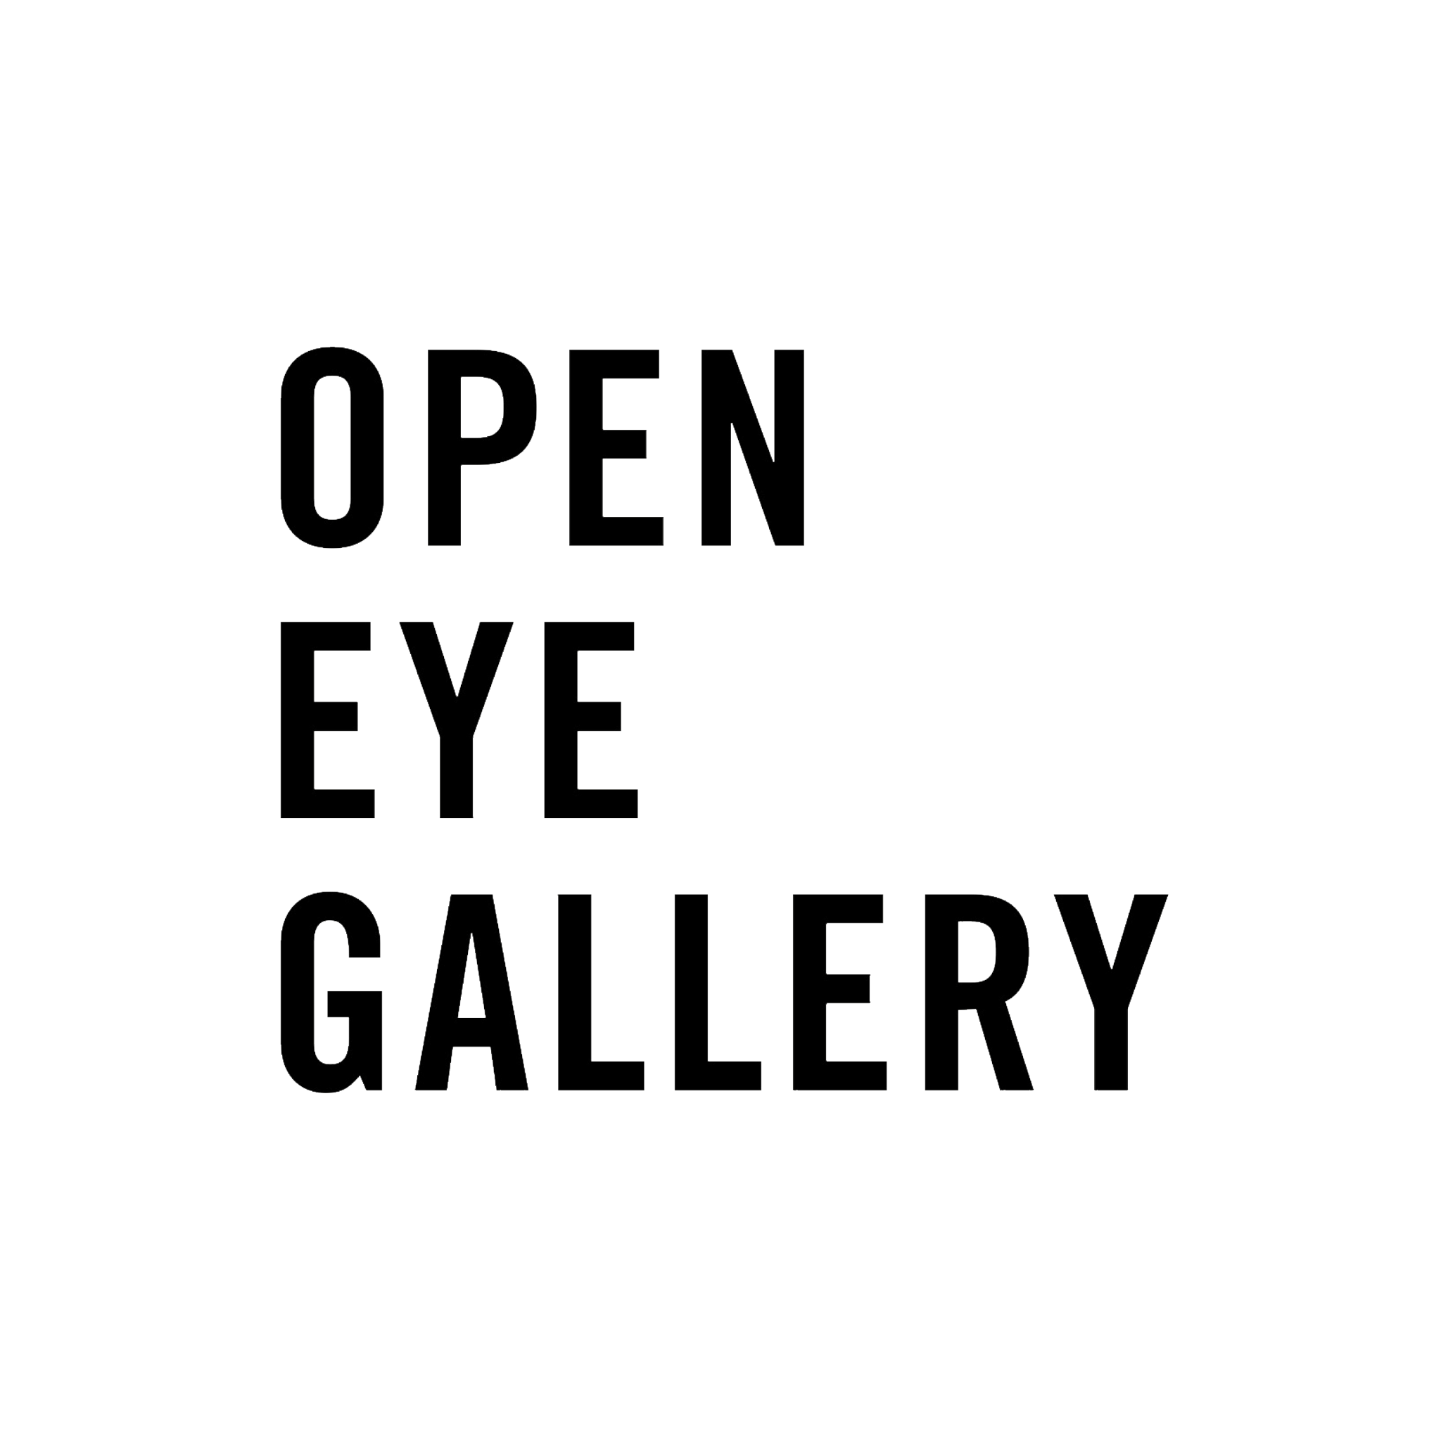

* 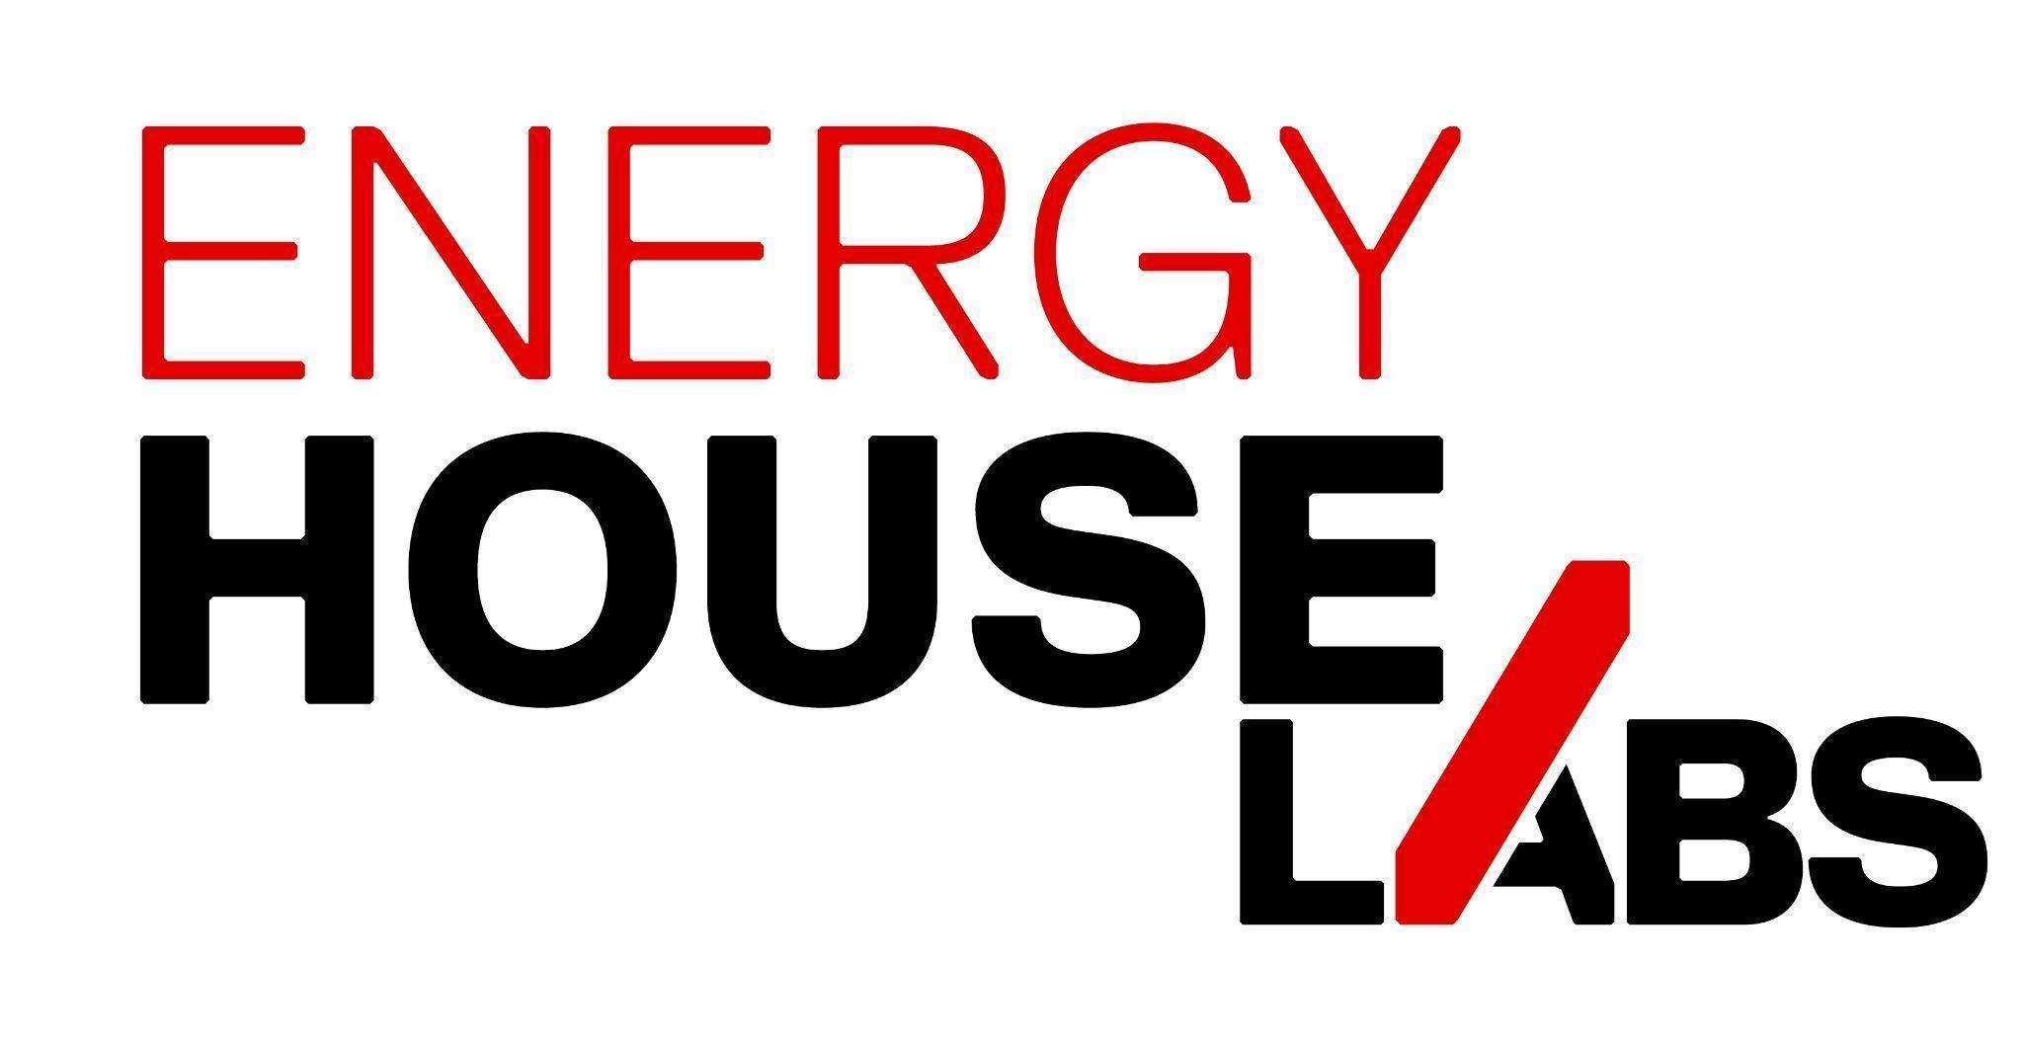*

**The Energy House 2.0 Artist Residencies have been hosted by the University of Salford Art Collection in partnership with Open Eye Gallery, Liverpool and Castlefield Gallery, Manchester. Both residencies have been made possible through funding from the Friends of Energy House 2.0 Community***.*

**This exhibition is generously supported with funding from Castlefield Gallery Commissioning Patron Professor Chris Klingenberg.**

Castlefield Gallery Funders and supporters:

