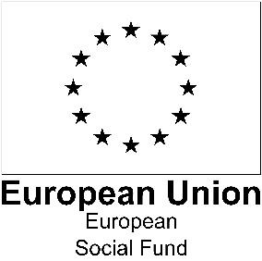
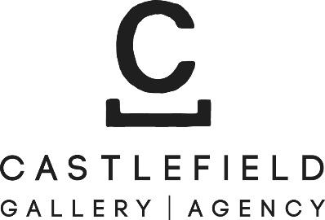

Application Form: bOlder 2021/22
Greater Manchester Visual Artist Development Programme for Artists aged 50+
Castlefield Gallery
Open to contemporary visual artists* aged 50+ living in Greater Manchester
Application deadline: 12 noon, Monday 29th November 2021
If you have access requirements that could be a barrier to applying or taking part in this programme, please contact Jane Lawson at jane@castlefieldgallery.co.uk or on 0161 832 8034.
Please note Castlefield Gallery office hours are Tuesday–Sunday, 10am–6pm. Castlefield Gallery offices are closed on Mondays.
*We welcome applications from artists working across mediums in the visual arts including, but not limited to: drawing, painting, printmaking, photography, sculpture, installation, artist’s film, moving image, sound, live art, public art, socially engaged practices, design and craft.
Applicants must be able to demonstrate that they are unemployed or economically inactive, meaning that they are not doing any kind of paid work at the start of the programme.
Application form
- Your contact details.
[Boxes will expand as you write into them]
Name:
Home Address:
Mobile:
Landline:
Email:
Website:

- Please tell us in brief about yourself and your art practice (up to 200 words)

- What personal, artistic and professional benefit do you hope to get from participating in this Development Programme? (up to 200 words)

- Are there any particular areas of professional development that you would like to cover – e.g. communicating more confidently, interpersonal skills, writing applications, identifying opportunities, (up to 200 words)

The bOlder programme begins in December 2021. Please can you confirm your availability for the group induction session and individual introductory session. Please mark all the dates/times that you are currently available.
I am available for the group induction session on
Monday 13th December, 4:30-6:00 pm Yes No
Monday 13th December, 6.30-8:00 pm Yes No
I can attend this session face-to-face Yes No
I am available for an individual enrolment session on
Monday 6th December Yes No
Tuesday 7th December Yes No
Monday 13th December Yes No
I can attend the enrolment face-to-face Yes No

Please let us know any time constraints you have, e.g. only available after 12.
If you aren’t available on these dates, please let us know when you are available between 6th and 13th December.
- Please provide the name and contact details of a referee who is familiar with your artistic practice.
Referee Name:
How do you know the referee?
Email:
Phone:

- Is there anything else we should know? e.g. if you have access requirements or if it will be difficult for you to attend sessions face-to-face

- Your work
Please include images and/or video/sound files of your work (maximum 6 images or 5 minutes total of video/sound).
Please submit video or sound files as links, via WeTransfer https://wetransfer.com or (if you are posting your application) on a USB stick.
Please title any images, video and sound files with your full name, the title of the work and the year of production. For images, please also include information about media and dimensions.
- Please let us know how you found out about this opportunity:
Castlefield Gallery mailout
Castlefield Gallery Associates mailout
Castlefield Gallery website
Other mailout
Other web site (please say which)
Poster (please say where)
Press
Social media
Word of mouth
Other (please say where)
Sending your application
You can apply by post, online form or by email. To apply by post, please send your completed application form and diversity survey and examples of your work to Castlefield Gallery, 2 Hewitt Street, Manchester M15 4GB, to arrive by 12 noon, Monday 29th November 2021. Please let us know if you would like us to send you hard copies of the application form and diversity survey.
To apply by email, please send the following to Programme Administrator Leslie Remonato at leslie@castlefieldgallery.co.uk to arrive by 12 noon, Monday 29th November 2021. Please put bOlder 2021/22 Application in the email header:
- Your application form with your full name in the file name, e.g. Jan_Smith_bOlder_Application, including images and/or video/sound files of your work
(maximum 6 items or 5 minutes total of video/sound).
- Please submit video or sound files as links in the application form or via WeTransfer https://wetransfer.com
- Please title any images, video and sound files with your full name, the title of the work and the year of production, e.g. Jan_Smith_Still Life in Blue_2020.
- Your up-to-date CV including links to any relevant websites (in 1 pdf file, with your name first in the title e.g. Jan_Smith_CV).
- A completed diversity monitoring survey

If you have access requirements that could be a barrier to applying or taking part in this programme, please contact Jane Lawson at jane@castlefieldgallery.co.uk or on 0161 832 8034.
Please note Castlefield Gallery office hours are Tuesday–Sunday, 10am–6pm. Castlefield Gallery offices are closed on Mondays.
Please note that we cannot consider late or incomplete applications.
Applications must be received by 12 noon, Monday 29th November 2021.
In submitting this application form you confirm that you meet the following eligibility conditions for the duration of the programme:
- You are a contemporary visual artists aged 50+, living in Greater Manchester (Bolton, Bury, Manchester, Oldham, Rochdale, Salford, Stockport, Tameside, Trafford or Wigan)
- You can demonstrate that you are unemployed or economically inactive, meaning that you are not doing any kind of paid work.
- You are not currently engaged in full-time education.
- You are available to participate over the full period of the programme.
- You can demonstrate that you have the legal right to live and work in the UK; this is a requirement of the European Social Fund.
Before starting the programme, successful applicants will need to supply us with evidence of their legal right to live in the UK during the period of the programme, such as a passport, residency permit or marriage/civil partnership certificate. If you’re unsure about whether you have the right evidence, please see this list of allowable evidence or contact Leslie Remonato at leslie@castlefieldgallery.co.uk or 0161 832 8034.
Before starting the programme, successful applicants will need to demonstrate that they are unemployed or economically inactive. Examples of suitable evidence would be evidence of pension income, a DWP/Jobcentre Plus benefits decision notification letter or a referral from Careers Service or similar. If you’re unsure about whether you have the right evidence, please see this list of allowable evidence or contact Leslie Remonato at leslie@castlefieldgallery.co.uk or 0161 832 8034.
Unfortunately, we cannot provide support to develop applications, other than for those with access needs, or give feedback on unsuccessful applications.

