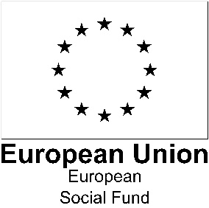
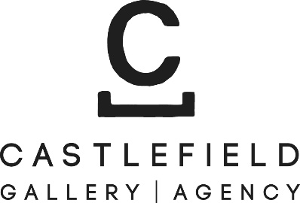

Application Form: bOlder 2020/21
Greater Manchester Visual Artist Talent Programme for Artists 50+
Castlefield Gallery
Open to contemporary visual artists* living in Greater Manchester
Application deadline: 12 noon, Monday 28th September 2020
If you have access needs that could be a barrier to applying or taking part in this programme, please contact Jane Lawson at associates@castlefieldgallery.co.uk or on 0161 832 8034.
At time of writing our premises remain closed; we are working towards reopening soon. If you need to contact us by phone, please ring 0161 832 8034 and leave a voicemail with your name, what you are calling about and your contact number and we will ring you back as soon as we can. Please note Castlefield Gallery office hours are Tuesday–Sunday, 10am–6pm. Castlefield Gallery offices are closed on Mondays.

*We welcome applications from artists working across mediums in the visual arts including, but not limited to: drawing, painting, printmaking, photography, sculpture, installation, artist’s film, moving image, sound, live art, public art, socially engaged practices, design, craft.
Application form
- Your contact details.
[Boxes will expand as you write into them]
Name:
Home Address:
Studio Address (if applicable):
Mobile:
Landline:
Email:
Website:

- Please tell us in brief about yourself and your art practice (up to 200 words)

- What personal, artistic and professional benefit do you hope to get from participating in this Talent Programme? (up to 200 words)

- Are there any particular areas of professional development that you would like to cover – e.g. communicating more confidently, interpersonal skills, writing applications, identifying opportunities, (up to 200 words)

The bOlder programme commences in October 2020. Please can you confirm your availability for the group induction session and individual introductory session.
I am available for the group induction session on
Monday 26th October, 4:30-5:30 pm Yes No
Monday 26th October, 6:30-7:30 pm Yes No

I am available for the individual introductory session on
Tuesday 27th October Yes No
Thursday 29th October Yes No
Friday 30th October Yes No
Please indicate any time constraints you have, e.g. only available after 12
If you have difficulty being available on these dates, please let us know what dates you are available between 26th October and 6th November

- Please provide the name and contact details of a referee

Referee Name:
How do you know the referee?
Email:
Phone:

- Is there anything else we should know? e.g. if you have access needs

- Your work
Please include images and/or video/sound files of your work (maximum 6 items).
Please submit video or sound files as links, via WeTransfer https://wetransfer.com or (if you are posting your application) on a USB stick.
Please title any images, video and sound files with your full name, the title of the work and the year of production. For images, please also include information about media and dimensions.

- Please let us know how you found out about this opportunity:
Castlefield Gallery mailout
Other mailout
Listings site (please say which)
Poster (please say where)
Press
Social media
Word of mouth
Other (please say where)

Sending your application
You can apply by post or by email. To apply by post, please send your completed application form and diversity survey and examples of your work to Castlefield Gallery, 2 Hewitt Street, Manchester M15 4GB, to arrive by 12 noon, Monday 28th September 2020. Please let us know if you would like us to send you a hard copy application form and diversity survey.
To apply by email, please send the following to Programme Administrator Leslie Remonato at leslie@castlefieldgallery.co.uk, with bOlder 2020/21 Application in the email header:
- Your application form (with your full name saved in in the file name, e.g. Janet_Smith_bOlder_Application)including images and/or video/sound files of your work (maximum 6 items).
- Please submit video or sound files as links in the application form or via WeTransfer https://wetransfer.com
- Please title any images, video and sound files with your full name, the title of the work and the year of production, eg Janet_Smith_Still Life in Blue (2017)_bOlder_Application).
- Your up-to-date CV including links to relevant websites (in 1 pdf file, with your name first in the title e.g. Janet_Smith_CV).
- A completed diversity monitoring survey

If you have access needs that could be a barrier to applying or taking part in this programme, please contact Jane Lawson at associates@castlefieldgallery.co.uk or on 0161 832 8034.
At time of writing our premises remain closed; we are working towards reopening soon. If you need to contact us by phone, please ring 0161 832 8034 and leave a voicemail with your name, what you are calling about and your contact number and we will ring you back as soon as we can. Please note Castlefield Gallery office hours are Tuesday–Sunday, 10am–6pm. Castlefield Gallery offices are closed on Mondays.

Please note that we cannot accept late or incomplete applications.
Applications must be submitted by 12 noon, Monday 28th September 2020.

PLEASE NOTE
In submitting this application form you confirm that you meet the eligibility criteria and conditions (subject to successful application:
- You are a contemporary visual artists aged 50+, living in Greater Manchester (Bolton, Bury, Manchester, Oldham, Rochdale, Salford, Stockport, Tameside, Trafford or Wigan
- You can demonstrate that you are unemployed or economically inactive, meaning that you are not doing any kind of paid work.
- You are not currently engaged in full-time education.
- You are available to participate over the full period of the programme.
- You can demonstrate that you have the legal right to live and work in the UK; this is a requirement of the European Social Fund.

