2 Hewitt Street, Manchester, M15 4GB, UK
www.castlefieldgallery.co.uk
+44 (0)161 832 8034

PRESS RELEASE INFORMATION – For immediate release
Launch Pad: Manchester School of Art 2013

1-10 November 2013

Castlefield Gallery is pleased to present new work by Calum Crawford, Sophie Mitchell and Darren Murphy, three graduates from the Manchester School of Art. The exhibition was co-selected by Castlefield Gallery’s Director Kwong Lee and Manchester School of Art, Head of Art and Associate Dean Penny Macbeth, from the 2013 BA (Hons) Fine Art and Interactive Arts degree shows. Launch Pad: Manchester School of Art 2013 is the first in a series of three annual exhibitions profiling the most promising artists coming out of the school.

Castlefield Gallery is continuing its significant and long standing partnership with Manchester Metropolitan University with the Launch Pad series of exhibitions. Over its 29 years history, Castlefield Gallery has worked with students, graduates, lecturers, researchers, course leaders and department heads as artists, advisors and experts in the field of contemporary art. The quality of graduating students from the BA (Hons) Fine Art and BA (Hons) Interactive Arts 2013 courses was exceptionaly high and we are really pleased to be able to platform three of the most promising artists from this year. Kwong Lee, Director, Castlefield Gallery

Castlefield Gallery is renowned for the exceptional work it does in showing and launching emerging artists work, Launch Pad: Manchester School of Art 2013 is a fantastic platform for our three graduates in this early stage of their career. This is the first of a series of three exhibitions which will take place annually, and it will help to raise the profile of artists graduating from Manchester School of Art. The artists will benefit from the exceptional mentoring provided by the Castlefield Gallery team and the opportunity to develop new work in response to an exhibition commission. Penny Macbeth, Head of Art, Associate Dean, Manchester School of Art

Exhibitions are places where artists, artworks and people intersect. The established behaviors that surround this collision are a source of material for Darren Murphy who seeks to provide contexts, rather than content for visitors to interact with. Calum Crawford merges appropriated footage and imagery with found or constructed 3D components, to deliver a romantic yet sometimes dark vision of popular culture. With her work Sophie Mitchell encounters the idea of the authentic and the idealised in photography, combining images with subtle sculptural elements.

Shown together their work contrasts the loud and colorful with the fragile and overlooked, the appropriated with the relational. While Crawford and Mitchell bring visuals into the gallery, Murphy will document visitor’s interactions with this situation, leading to further reflection outside of the exhibition. Though their works are distinct there are also points where they meet and overlap. Moving from the images taken from Mitchell’s childhood family photo album to Crawford’s references, drawn from what interests him in daily life and poplar culture, to Murphy’s ‘Artist Assistants’ employed as representatives of him and his work for visitors to Castlefield Gallery, the artist is both overtly present and conspicuous by his absence.

NOTES TO EDITORS

Launch Pads are short exhibitions or performances that punctuate Castlefield Gallery’s main exhibition programme providing artists and curators with the opportunity to use the gallery as a test bed for the production, display and consumption of contemporary art. Launch Pads feature emerging talent selected from CG Associate members’ submissions (three times a year) and from the MA and BA art courses at Manchester School of Art (once a year). For more information about CG Associates and Launch Pad visit www.castlefieldgallery.co.uk

Launch Pad: Manchester School of Art 2013 was co-selected by Castlefield Gallery’s Director Kwong Lee and Manchester School of Art, Head of Art and Associate Dean Penny Macbeth, from BA (Hons) Fine Art and Interactive Arts graduates. This collaboration is part of a strategic partnership between Castlefield Gallery and Manchester Metropolitan University’s MIRIAD and Manchester School Art, which includes research on and delivery of artist development activities.

Castlefield Gallery (CG) Founded in 1984, CG is one of Northern England's most active and successful organisations/agencies for developing emerging contemporary artists and practice. Its ambitious curated exhibitions programme responds to national and international trends, promoting artists at key stages of their careers, including subsequent Turner Prize nominees/winners and exhibitors at international festivals. Central to CG’s activities is an artist development programme including the CG Associates members scheme and the recently launched New Art Spaces. CG's vision is for the North to be where artists can develop work of international standing. Its mission is to nurture talent, explore cultural trends and deepen audience's relationship to contemporary art.

Listing information

Exhibition: Launch Pad: Manchester School of Art 2013
Preview: Thurs 31 Oct 2013, 6-8pm
Exhibition Dates: 1-10 November 2013
Venue: Castlefield Gallery, 2 Hewitt Street, Manchester, M15 4GB, (behind Deansgate train station)
Tel: 0161 832 8034
Web: www.castlefieldgallery.co.uk
Opening Times: Wed to Sun 1pm – 6pm
Admission: FREE. The gallery is fully accessible
HHilary Jack

For further information, images or to arrange interviews, please contact: Jennifer Dean, Communications and Audience Development Coordinator jennifer@castlefieldgallery.co.uk or Matthew Pendergast, Interim Programme Manager matthew@castlefieldgallery.co.uk T: +44 (0) 161 832 8034.

Launch Pad: Manchester School of Art 2013 at Castlefield Gallery has been selected in partnership with Manchester School of Art.

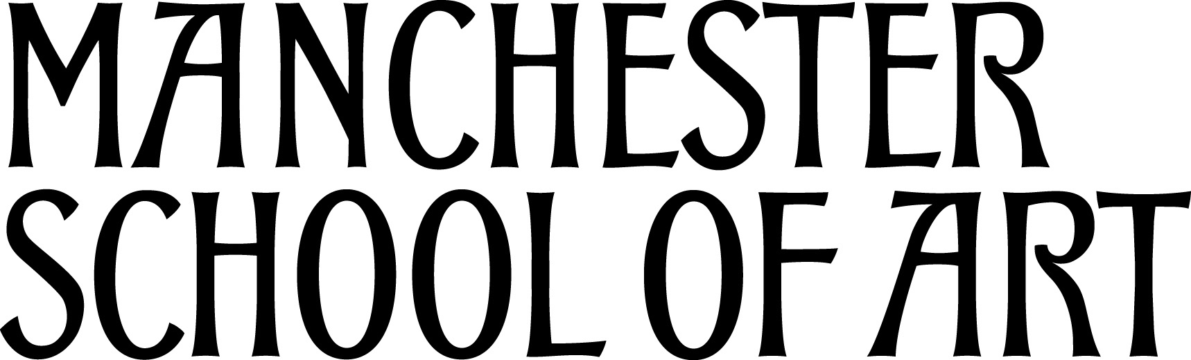

Castlefield Gallery’s Launch Pad programme is supported by Soup Kitchen, Manchester.

Castlefield Gallery is supported by Arts Council England through Grants for the Arts (2012-14) and is a cultural partner of Manchester City Council (2012-15).

