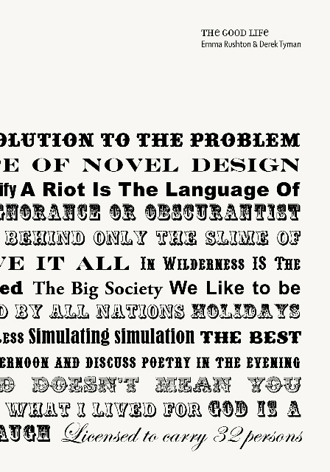
PRESS RELEASE INFORMATION – For immediate release

The Good Life cover designed by Axis Graphic Design

Artists Emma Rushton & Derek Tyman

Authors Andy Abbot, Anthony Iles, Virginia Nimarkoh, Lynsey Hanley, Steve Pool, Andy Webster, Janet Hodgson, Kwong Lee, David Osbaldeston

Pages 48

Binding Soft
- Illustrations 46 colour, 3 b&w

Dimensions 210mm x 148mm

Includes 4 track CD by Die Kunst

Price £10

ISBN 978-0-9559557-3-0

Published by

Castlefield Gallery Publications

www.castlefieldgallery.co.uk

Distributed by

Cornerhouse Publications

e:publications@cornerhouse.org

www.cornerhouse.org/books

Available to purchase from Castlefield Gallery and Cornerhouse Publications

The Good Life Book Launch with live performance by Die Kunst

Saturday 16 February 2013, 6 – 9pm

Castlefield Gallery is pleased to be launching The Good Life, a new book by artists Emma Rushton & Derek Tyman, and the latest publication from Castlefield Gallery Publications. Plus join us afterwards at Lionel Dobie Projects for a live performance by art rock band Die Kunst.

The Good Life documents a project by Rushton & Derek, realised over six months at two sites in the Lake District in 2011.
In association with Lanternhouse Arts Centre, a cabin – a copy of writer Henry David Thoreau’s, was constructed in Miterdale Forest and employed as a dwelling for artists, writers and musicians. A counterpoint to the cabin, The Good Life Stage, occupied a space at Lanternhouse. Painted with quotations by philosophers, writers and typographers it hosted a series of events and talks.

The Good Life book includes resulting works by artists Janet Hodgson, Kwong Lee, David Osbaldeston, Steve Pool and Andy Webster alongside texts by speakers Lynsey Hanley, Virginia Nimarkoh, Edward Skidelsky and essays by Anthony Iles and Andy Abbot. A 4 track CD by Die Kunst playing live on The Good Life Stage is included in the publication.

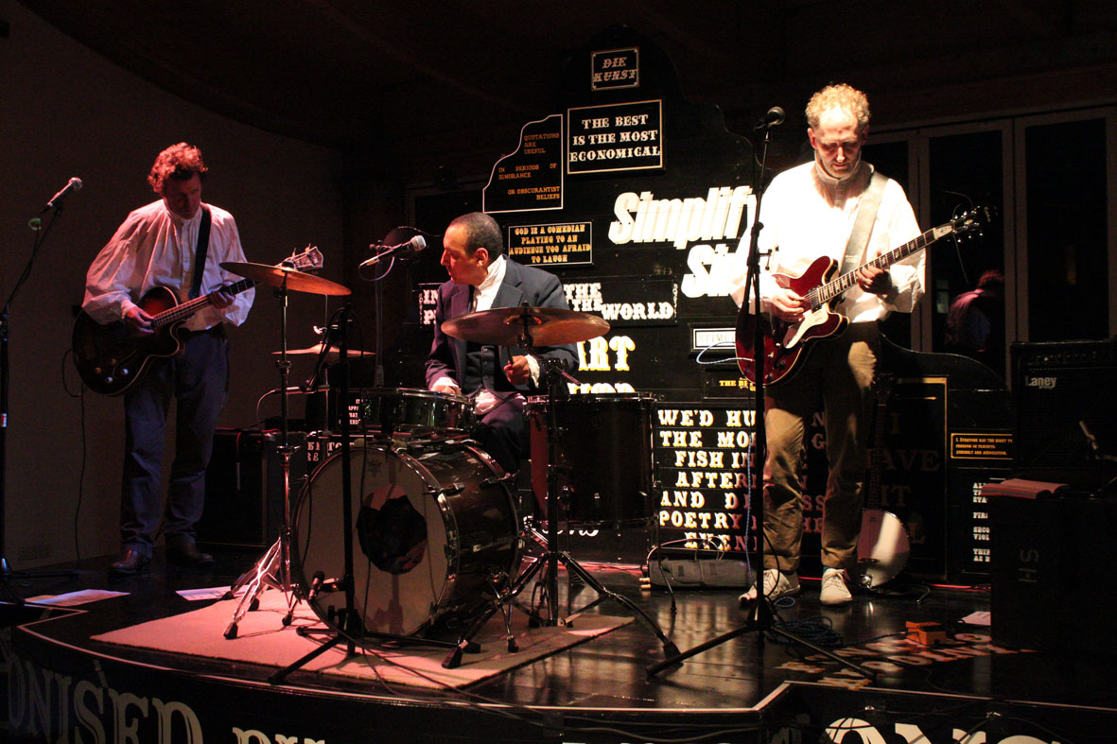

Die Kunst performance at Lanternhouse 15/10/2011 Photo: Fern Oxley
Further information: In 1845 Henry David Thoreau, an American writer, moved into a cabin in the woods at Walden Pond, a mile-and-a-half from the town of Concord, Massachusetts. He was to live in his self-built cabin for two years, two months and two days and while there began writing Walden; or Life in the Woods and Civil Disobedience.

Walden is a detailed account of his time in the woods and recounts his attempts to live a life of necessity, stripped of luxuries in order to better understand what is socially just and how to live a ‘good life’. In his influential text Civil Disobedience he presents an argument for individual resistance to civil government in moral opposition to an unjust state.

From April to September 2011 walkers through Miterdale forest, a mile and-a-half from Eskdale village in England’s Lake District, may have happened upon a cabin. The structure, covered in wood shingles, measuring 13ft high, 15ft long and 10ft wide was constructed by artists Emma Rushton and Derek Tyman. Their Thoreau Cabin, made from images and plans of a reconstruction of Thoreau’s cabin that now sits in Walden woods, formed part of The Good Life - a year-long project and residency at Lanternhouse Arts Centre in Ulverston, Cumbria.

Over the six months it was sited in the woods, 25 artists, writers and academics were invited to stay in The Thoreau Cabin. Janet Hodgson, Kwong Lee, David Osbaldeston, Steve Pool, Andy Webster and the three-piece art rock band Die Kunst were commissioned by Rushton and Tyman and Lanternhouse to produce work in response to the project.

In counterpart to the relatively isolated cabin, Rushton and Tyman constructed a working stage to occupy the main space at Lanternhouse. The Good Life Stage, installed within the existing architecture of the space and hand painted with quotations by philosophers, writers, typographers, was to host a series of events and talks over the same six months. Local activist Steve Johnson ran a series of Philosophy Cafés, a week-long music festival of local bands entitled Lanternhouse Live was held, and Lanternhouse programmed a number of events, including the on-going performance work Anniversary – Acts of Remembrance by artist Monica Ross. Writer Lynsey Hanley, philosophers Peter Marshall and Edward Skidelsky, visual anthropologist Amanda Ravetz and artists Virginia Nimarkoh and Andy Webster were invited by Rushton and Tyman to address ‘the good life’.

All the machinations of predatory trans-national markets, the baneful influence of banks and speculators… these could be countered, checked and made irrelevant. As globalisation deepens and trans-national companies gain more economic and political power there is a growing counter movement, and whether it’s the machine of organised work, industrial exploitation or coercive authority we can, as Thoreau suggested, cause ‘counter friction to the machine’.
Peter Marshall on The Good Life Stage, 21 July, 2011

In Civil Disobedience Thoreau defends the validity of conscientious objection to unjust laws, which ought to be transgressed. Although at times sounding as if Thoreau is advocating anarchy, what he demands is better government. He refuses to acknowledge the authority of one that has become so morally corrupt as to lose the consent of the governed.

Rushton and Tyman were not attempting to define The Good Life in their project, but in an era in which “reform and compromise with established powers no longer appears possible” (Anthony Isles, Dwelling and Debt, in The Good Life) they were intent on establishing concentrated spaces of place and time where our ‘Have It All’ culture could be debated and alternatives articulated.

More on Emma Rushton & Derek Tyman
Rushton & Tyman work collaboratively. Recent solo exhibitions include:
Argument, Tilburg and Artis Art Centre, Den Bosch, The Netherlands; Neues Kunstforum, Koln, Germany; 1a Space, Hong Kong, China.

More on Die Kunst
Die Kunst is an ongoing musical collaboration between Richard Hylton (curator and writer), Martin Vincent (artist publisher and writer) and David Mackintosh (artist). The collaboration takes the form of an experimental rock band, performing its particular brand of ‘rock’ in art galleries or at other special events associated with art galleries and artists’ presentations. Die Kunst have been working together since 1997 and have produced two albums; Sweden and Finland and one vinyl 7inch record, fast and loud/ slow and quiet. They have also produced a live soundtrack to Paul Wegener 1920 film DerGolem: wie er in die Welt kam which they have performed in New York, Plovdiv, Holland and Bradford. In 2009, Die Kunst was commissioned by Artis Den Bosch, Holland to perform a reinterpretation of Hawkwind's 'Silver Machine' for the opening of a solo exhibition by John Timberlake. For Viva, The Regular Cornerhouse Spanish Film Festival in 2010 Die Kunst presented musical accompaniments to a selection of Segundo De Chomon’s early short films. For more information about Die Kunst: mail@diekunst.org.uk or www. diekunst.org.uk

Event: The Good Life Book Launch with live performance by Die Kunst

Book Launch: Sat 16 Feb 2013, 6-7pm
Castlefield Gallery, 2 Hewitt Street, Manchester, M15 4GB
Performance: Sat 16 Feb 2013, 7-9pm
Lionel Dobie Projects, 91 Hewitt Street, M15 4GB
Booking: FREE / Booking not required

Web: www.castlefieldgallery.co.uk

For further information, images or to arrange interviews, please contact: Jennifer Dean, Communications Coordinator e: jennifer@castlefieldgallery.co.uk. t: +44 (0) 161 832 8034.

Castlefield Gallery is supported by Arts Council England through Grants for the Arts and is part of Manchester City Council’s Cultural Partnership Agreement portfolio.



The Good Life is also supported by:
