PRESS RELEASE INFORMATION – For immediate release

Exhibition: Life in the UK / Balance of Probabilities:
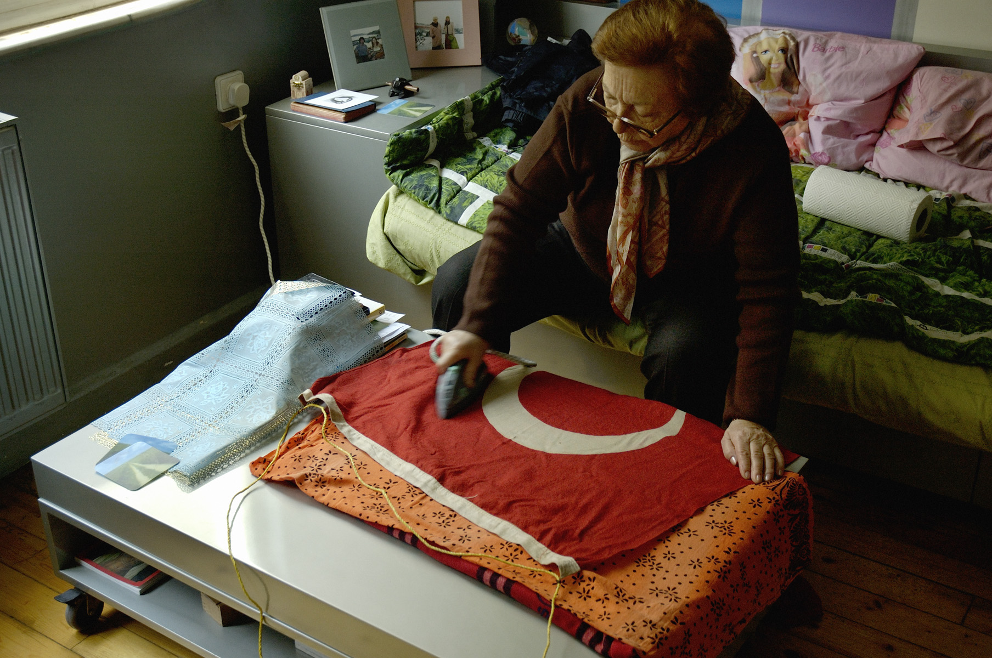

Artists: Didem Özbek & Osman Bozkurt

of PiST///

Preview: Friday 30 Sept 2011, 5-9pm
Exhibition Dates: 1 Oct to 27 Nov 2011

Venue: Castlefield Gallery, 2 Hewitt Street,
Manchester, M15 4GB
Telephone: 0161 832 8034

Website: www.castlefieldgallery.co.uk

Opening Times: Wed to Sun 1pm – 6pm
Osman Bozkurt, Ironing, 2009

Admission: FREE. The gallery is fully accessible
HHilary Jack

Castlefield Gallery is pleased to present Life in the UK / Balance of Probabilities, a debut UK commission by Istanbul based artists Didem Özbek and Osman Bozkurt of PiST/// for the Asia Triennial Manchester 2011. As the only artists to participate in the Triennial from Turkey, this project focuses on the issue of freedom of travel exploring one of the most salient issues of our time; the movement of people from one place to other parts of the world, whether for leisure or immigration.

For this ambitious multi artform project, PiST/// will transform the gallery into a temporary VISA Application Centre using the exterior and interior of the gallery as a mechanism to explore real stories fused with history and fiction. Examining the growth of the VISA ‘industry’ in Istanbul as its starting point, the project that combines the theatrical and participatory with installation and film, will explore the radical impact that migration has had on demography, identity politics, global economic changes, community and belonging.

This exhibition is co-curated by Lora Sariaslan and Castlefield Gallery.

Further information on:

Osman Bozkurt b. Istanbul 1970 is a photographer and video artist. He was recently featured in the Independent newspaper as one of the world’s ‘up and coming international artists’, nominated by Alistair Hicks, art advisor for the Deutsche Bank Collection. His work has been exhibited at the Tate Modern; Platform Garanti Contemporary Art Centre, Istanbul; Villa Manin Centro d’Arte Contemporanea, Udine; Palais des Beaux-Arts, Lille; Frieze Art Fair, 2008 among many others.

Didem Özbek b. 1970 lives and works in Istanbul. Her work has been exhibited at Akbank Sanat, Istanbul; Umetnostna Galerija Maribor; International Design Centre Nagoya among others. She also developed and created other conceptual projects for PiST such as Artist Information, Tea Stand and White Sugar Cube Book.

PiST/// is an interdisciplinary project space that creates new platforms for discourse and presentation from young and emerging artists, writers, critics, architects or musicians to generate an international dynamic in the art scene of Istanbul and Turkey. Located on 3 neighbouring shop fronts in Pangalti, Istanbul, PiST/// is an independent project run by artists Didem Özbek and Osman Bozkurt founded in May 2006.

For further information & images please contact: Jennifer Dean, Communications Coordinator jennifer@castlefieldgallery.co.uk. Castlefield Gallery, 2 Hewitt Street, Manchester, M15 4GB. T: +44 (0) 161 832 8034.

