Recruitment of Artist Representative to the Board of Directors & Trustees
of Castlefield Gallery

Castlefield Gallery is the centre to the periphery, which in my thinking is the best position to work from and where I want to be. Castlefield Gallery oozes with explorers and pioneers, and understands that the currency of a scene is its ability to import and export culture, not sit stagnant in its own melting pot. Ryan Gander, OBE, Artist and Patron of Castlefield Gallery

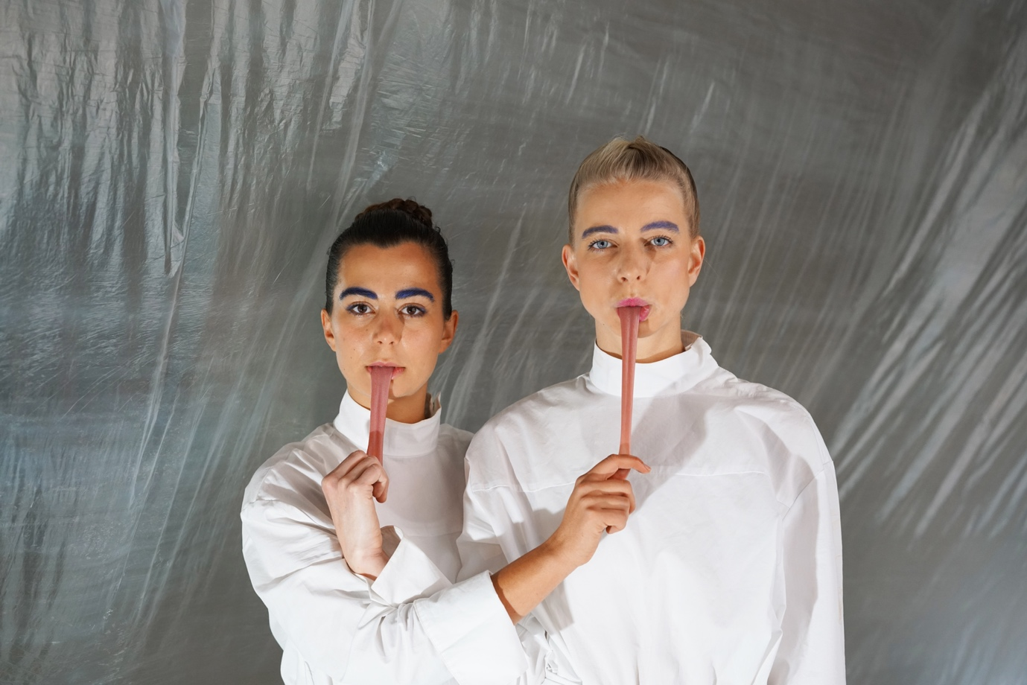
CMMC, Friends call me Gass, 2017. Image courtesy Kieran Leach

Introduction
Thank you for your interest in Castlefield Gallery.
Established by artists in 1984, Castlefield Gallery was Manchester’s first public contemporary visual art gallery to have opened in the city, and over the last three decades has been a significant catalyst for the region’s cultural growth.
Castlefield Gallery is a National Portfolio Organisation of Arts Council England and a Manchester City Council Cultural Partner for 2018/19 – 2021/22. Castlefield Gallery is a registered charity and a company limited by guarantee. The trustees of the charity are also board members of the company.

As an artist focused organisation looking forward to our 40-year anniversary in 2024, we are seeking to grow artist representation on the Castlefield Gallery Board of Trustees. We are in particular looking to engage an artist Trustee living and /or working in the North West of England and working at an early career to mid-career stage.
The successful candidate will have a portfolio lead in the area of artistic and career development, complementing the activities of our current artist representative Ian Rawlinson and the Castlefield Gallery team.
This role is voluntary and reasonable expenses are reimbursed. The Board currently meets in Manchester a minimum of four times annually, with additional occasional meetings and subcommittee group meetings.

Information included:
- About Castlefield Gallery
- List of Current Staff and Board Members
- Roles and Responsibilities of the Board
- Attributes and Eligibility Criteria
- Selection and Appointment Process

About Castlefield Gallery
Our Mission is to nurture talent, explore cultural trends and deepen its audience’s relationship to contemporary art.
Our Vision is for Castlefield Gallery to be an artist-focused gallery and national hub dedicated to artistic and career development in the visual arts, enabling artists to live and work in the North of England whilst achieving national and international success.

Our Values:
- Collaborative
- Current
- Progressive
- Resourceful
- Inspiring

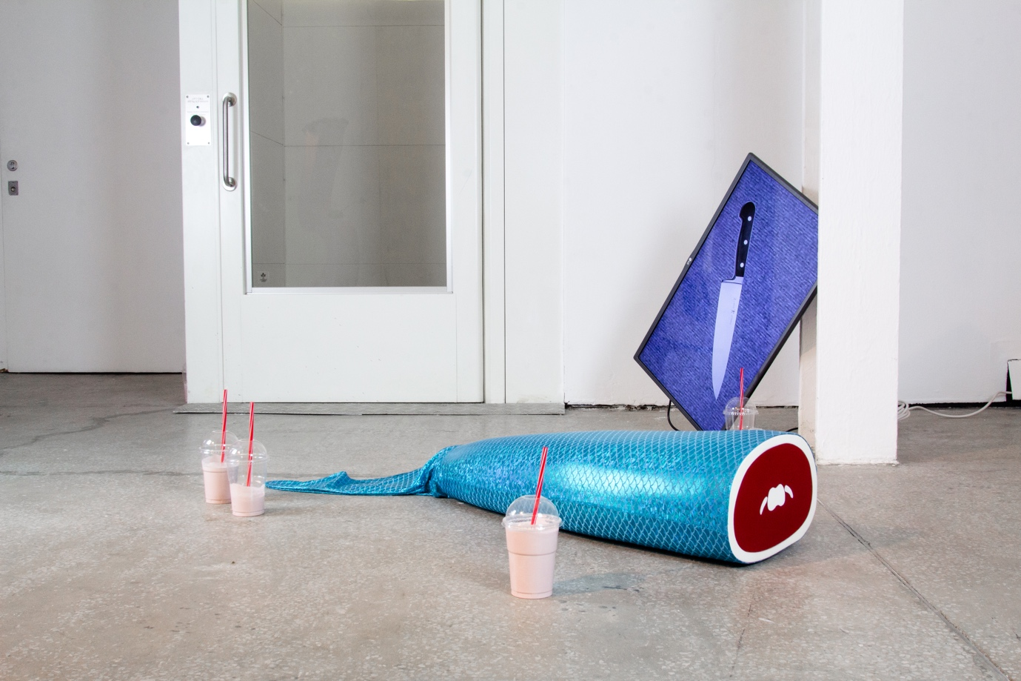
Richard Hughes, None of Us Are Cute, 2017. Image courtesy Annie Feng

Castlefield Gallery delivers a programme of exhibitions, projects and events from our main gallery in central Manchester, whilst also commissioning, curating and producing off-site and public art, national and international artist residencies, and exchange programmes. We export art and culture developed and produced in the region through exchange, so as to enable meaningful relationships between artists nationally and internationally to flourish over extended periods of time.

Partnership is at the heart of everything we do. Last year alone, our work has delivered exchanges and residencies for artists between the Greater Manchester region and North West of England, with Budapest, Geneva, Glasgow, London, Prague, and S. Korea (Busan & Gwangju).
Castlefield Gallery Associates is a 200+ strong artist, curator and writer membership group who access artistic, skills and career development support via our work, as well as New Art Spaces - pop-up art and production spaces located across Greater Manchester. Our development programme extends to providing bespoke artist mentoring, coaching and CPD, working with those at all career stages, including new graduates. We subsidise this activity to keep costs for artists and our members affordable.
We are a proven leader and enabler in the development of visual artists, with many Castlefield Gallery ‘alumni’ going on to experience national and international acclaim, including Turner Prize winners and nominations, exhibitors at major festivals, biennials, triennials and international presentations.
Until the end of August 2019 Castlefield Gallery is a recipient of Arts Council England’s Catalyst: Evolve, an initiative that encourages the growth of private giving and organisational resilience. For this time-limited period Arts Council England will match each new donation we secure pound-for-pound, doubling the impact of each pledge made to support our work.
The Castlefield Gallery Business Plan is set for the period 2018/19 – 2021/22, paving the way for our vision towards 2024 when we will celebrate our 40th year. The Business Plan is reviewed and renewed annually.
Our 10-year Business Strategy is in its final phase a period during which the organisation will:
- Further test, grow and embed our new income streams and our entrepreneurial activity
- Refine our governance and operational model
- Develop and embed our high value partnerships
- Consolidate our programme, ensuring it is recognised for its quality and impact, at home, nationally, and abroad
- Grow our long-term stakeholder commitments
- Futureproof our business strategy through review and renewal from 2020

To find out more about Castlefield Gallery visit www.castlefieldgallery.co.uk

Castlefield Gallery’s Board

The Castlefield Gallery Board is a portfolio board. Members are drawn from diverse backgrounds, with skills or experience in particular areas. Board members are not expected to take on sole responsibility for their area of expertise, as the Board is collectively responsible for its decisions and actions. Trustees are expected to involve themselves in committees and other matters according to their particular interests and skills, as well as their ‘Portfolio’ lead.

Our Board currently comprises:

- Marla Cunningham, Chair (Portfolio Lead – Fundraising & Development)
- Kate Jesson, Vice Chair (Portfolio Lead - Artistic Programme)
- Mike Ariss (Treasurer and Portfolio Lead – Finance & Financial Strategy)
- Barney Leaf (Portfolio Lead - Legal)
- Elaine Higgins (Portfolio Lead - HR)
- Beth Knowles (Portfolio Lead - Communications & Strategy)
- Ian Rawlinson (Portfolio Lead - Artistic Programme / Artistic & Career Development)
- Roger Stephenson OBE (Portfolio Lead – Architecture & the Built Environment)
- Adrian Slatcher (Portfolio Lead – to be appointed to Company Secretary)

Our Staff team currently comprises:
- Helen Wewiora, Director (F/T)
- Matthew Pendergast, Curator (P/T)
- Jennifer Dean, Communications & Audience Development Coordinator, and Individual Giving Manager (P/T)
- Nicholas James, Facilities and New Art Spaces Coordinator (P/T)
- Jane Lawson, Castlefield Gallery Associates Coordinator (P/T)
- James Matthew-Hiskett, Finance & HR Coordinator (Maternity Cover, P/T)
- Alexandra Barker, Development, Finance & HR Coordinator (Maternity, P/T)
- Emil Margraine, Creative Apprentice, Digital Marketing & Communications
- We currently host Erasmus, international internships and local placements
- A team of volunteers

Roles and Responsibilities of the Trustees of the Board
The Board’s role is to:
- Provide constructive strategic leadership and support to fulfil the organisation’s strategic aims and objectives, and in line with charity and company law as well as other regulatory requirements
- Provide high level governance and overview, within a framework of prudent and effective controls which enable risk to be assessed and managed
- Approve mission and vision, guiding and upholding organisational values, and ensuring that its obligations to its stakeholders and others are understood and met
- Take an active role in the preparation and approval of the business strategy, plan, annual budgets, major resource issues, including human resource, and policies
- Safeguard Castlefield Gallery’s financial stability, including approving the annual accounts
- Advocate proactively for the organisation
- Attend board meetings, subcommittees and other events
- Assist and advise on selected projects in line with portfolio responsibilities

Attributes and Experience
Trustees are expected to have:
- A passion for and commitment to contemporary visual art, Castlefield Gallery’s mission, vision and values
- The ability to dedicate time and effort to supporting the organisation, and willingness to play an active role
- A successful track record of working in their field
- Strong communication and influencing skills
- Relevant, stablished and diverse professional networks
- An acceptance of the legal duties, responsibilities and liabilities of the trusteeship of a charity
- A good understanding of cultural, artistic, economic, social and political context that Castlefield Gallery operates in
- The ability to operate as a member of a team, experience of committee work, and to both inspire others
- A commitment to equality and diversity
- A willingness to take a proactive role in the whole of the business
- Good, independent judgment with a desire to work in the best interests of Castlefield Gallery, without regard to personal interest or benefit
- The ability to think creatively alongside ability to focus on practical issues
- The willingness to speak their mind
- Tact and diplomacy
- Impartiality, fairness and the ability to respect confidences
- No significant conflicts of interest

Eligibility

Board members are required to act reasonably and prudently in all matters relating to Castlefield Gallery and must always bear the interests of Castlefield Gallery in mind. They must also be prevented from acting as a trustee if they:
- Have an unspent conviction for an offence involving dishonesty or deception
- Are currently declared bankrupt (or subject to bankruptcy restrictions or an interim order)
- Have an individual voluntary arrangement (IVA) to pay off debts with creditors
- Are disqualified from being a company director
- Have previously been removed as a trustee by the Charity Commission or the High Court due to misconduct or mismanagement
- Are disqualified or barred from acting as a trustee of this charity under the Safeguarding Vulnerable Groups Act 2006
- Although selection as a Trustee is not a public appointment, the seven principles of public life as defined by the Nolan Commission (selflessness, integrity, objectivity, accountability, openness, honesty and leadership) are applicable to this role

For further information about charities and being a trustee please visit https://www.gov.uk/running-charity/trustee-role-board

Useful information:
- Quarterly meetings are held in Manchester, approximately every three months, with an additional extended meeting to include the AGM, normally in November
- In the summer of 2017 Castlefield Gallery held a joint Board and Staff away day, and this is something we look to build on in future
- Castlefield Gallery board members offer their services on a voluntary basis but can be reimbursed for travel and any other expenses, within reason, related to their work as a board member, in agreement with the Director and the organisation’s annual budget
- Board members are provided with a full induction and can be supported with training opportunities as required
- There are a number of sub-committees / task groups which are led by Board members, and include relevant staff where appropriate
- Castlefield Gallery aims for its board members to reflect the diverse communities of the UK and this is a current priority for the Board
- There is an expectation that members attend at least 50% percent of the board meetings each year. Attendance can be ‘virtual’ if attendance in person is not possible.

Selection & Appointment Process
Application
Please submit:
- A Curriculum Vitae (CV) identifying your main achievements to date. Please also include two referees and their full contact details (no more than two sides of A4, and referees will only be contacted with your prior agreement if you are invited to interview and confirm attendance at interview)

- A cover letter outlining relevant skills and experience for this role. Please state clearly why you are applying to the role of Artist Representative on the Board of Trustees of Castlefield Gallery and what particular attributes you will bring to the position (no more than two sides of A4). Please ensure you disclose any potential conflicts of interest at application stage

- Completed Equality Monitoring Questionnaire. Please send the monitoring form separately to ensure it remains anonymous. Please note your answers will be treated in confidence and used for statistical monitoring purposes only and will not be seen by the panel of decision makers

Castlefield Gallery is committed to promoting equal opportunities, and encourages applicants from all sections of the community.

Please submit your application materials to: recruitment@castlefieldgallery.co.uk
Or by post to:
Recruitment Castlefield Gallery
2 Hewitt Street
Manchester
M15 4GB

Shortlisting & interviews
Key dates
- Closing date for applications: Friday 7 September 2018, 6pm.
- Shortlisted applicants to be informed and invited to interview by: Tuesday 11 September 2018, 6pm.
(Please note, we will not be able to provide feedback to applicants not shortlisted for interview).
- Interviews will be held in Manchester on: Friday 21 September 2018 between the hours of 10am – 6pm.
- Reasonable travel expenses will be paid for travel to interviews, including costs for overnight accommodation if required. We will endeavour to notify those interviewed the outcome of the interview process by no later than Wednesday 26 September 2018, 6pm.
- The Castlefield Gallery AGM will be on the evening of Thursday 29 November to which the successful candidate will be invited for formal appointment.

For further information or an informal and confidential discussion about this opportunity, including speaking with the current Director and Chair or Vice Chair of Castlefield Gallery, please direct your request to recruitment@castlefieldgallery.co.uk or call 0161 832 8034.

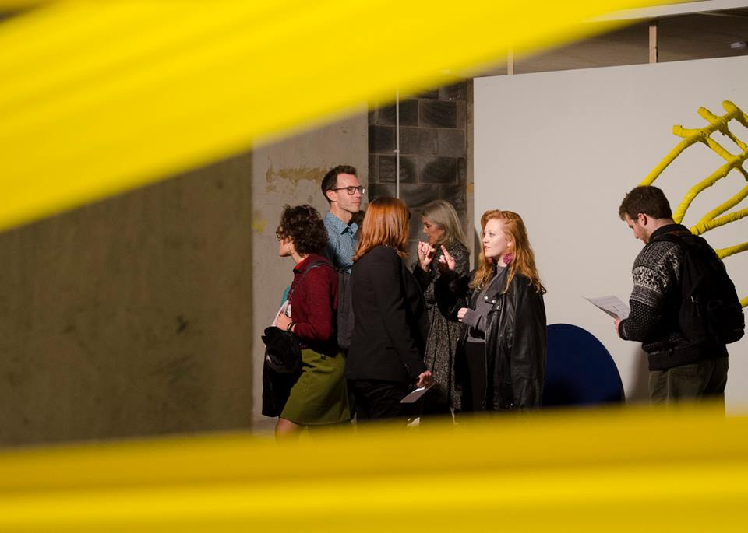
Castlefield Gallery New Art Spaces: Great Northern Tower. Image courtesy John Lynch

We look forward to hearing from you and thank you for your interest in Castlefield Gallery.
