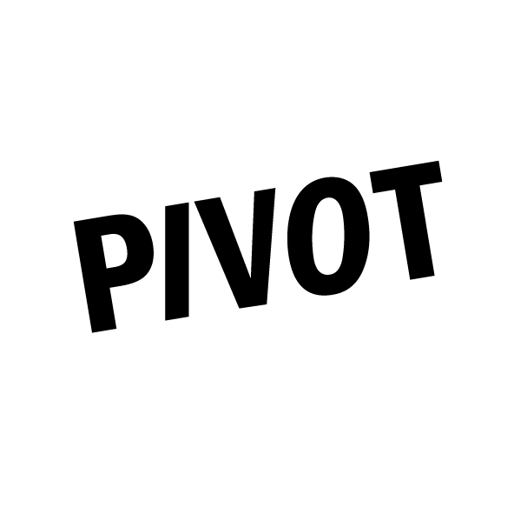

Application Form

PIVOT: an 18 month development programme for mid-career artists living and working in the North West of England, developed and delivered by Bluecoat and Castlefield Gallery.

We welcome applications from mid-career contemporary visual artists working across mediums in the visual arts including, but not limited to: drawing, painting, printmaking, photography, sculpture, installation, artists film and film & video, sound, live art, public art, socially engaged practices, design, craft.

The North West of England is one of nine official regions of England and consists of the five counties Cheshire, Cumbria, Greater Manchester, Lancashire and Merseyside.

Application deadline: 12 noon, Wednesday 30 September 2020
Online Interviews: Thursday 8 and Friday 9 October 2020

Access, Equality and Diversity
Bluecoat and Castlefield Gallery are committed to the promotion of equal opportunities in all aspects of our work, including management, employment practices with both paid workers and volunteers, access to services and service provision. We fully support the principles of equality and diversity. We recognise that groups and individuals in society are disadvantaged due to discrimination directed against them. We aim to remove any barriers, bias or discrimination that prevents individuals or groups from realising their potential and to develop organisational cultures that positively value diversity. Our venues are fully wheelchair accessible and assistance dogs are welcome on both sites.

We are aware that not everyone has internet access and access to IT equipment at home, and will take steps to make sure that this is not a barrier to anyone’s participation.

If you have access needs that could be a barrier to applying or taking part in this programme, please contact pivot@thebluecoat.org.uk A reply will follow in 48 hours or less.

Application form
[The below boxes will expand as you write into them]

- Your contact details and personal information.
Name:
Home Address:
Studio Address (if applicable):
Mobile:
Landline:
Email:
Website:
Social:

- Please tell us about yourself, your art practice and career. (up to 200 words)

- What personal, artistic and professional benefit do you hope to get from participating in PIVOT? Please carefully consider the aims and core components of the programme in your response which are outlined in the call for applications and guidance document. (up to 200 words)

- Is there anything else you would like to add or want to make us aware of for consideration? e.g. if you have access needs, other personal circumstances you might want to make us aware of, or personal circumstances that mean receiving a cash bursary would cause difficulties, such as being in receipt of benefits for example? (up to 200 words)

- Please provide the name and contact details of a referee, preferably an established artist or arts professional who knows your practice well enough to recommend you for this programme.
Referee Name:
How do you know your referee?
Email:
Phone:

- PIVOT commences early November 2020. Please can you indicate your availability for the group introduction and induction session, first 1-2-1 session, and first coaching session.
I am available for the introduction and induction session on:
Monday 2 November 11am – 12 noon Yes No
Tuesday 3 November 6.30-7.30pm Yes No

I am available for my first 1-2-1 session on:
Thursday 12 November Yes No
Friday 13 November Yes No
Tuesday 17 November Yes No
Please indicate any time constraints you have, e.g. only available after 12noon:

I am available for my first coaching session in December. Please indicate available dates, Monday – Friday and any time constraints you have, e.g. only available after 12noon, for the period: 18 November – 18 December 2020:

If you have difficulty being available on these dates, please let us know what dates you are available between 2 November and 18 December 2020 and indicate any time constraints eg. I am only available between 11am – 2pm.
Submitting your application
Send the below to pivot@thebluecoat.org.uk with the subject PIVOT in the email header or by post to PIVOT applications, Bluecoat, School Lane, Liverpool, L13BX.

- Completed application form saved as a pdf (with your name first in the title, eg. firstname_surname_PIVOT_Application).
- Visual or audio material images and/or video/sound files of your work
Maximum 12 images or up to 15 minutes of video or audio work.
- Please submit video or sound files as links in the application form or via WeTransfer https://wetransfer.com to pivot@thebluecoat.org.uk with the subject PIVOT in the message header.
- Please title any images, video and sound files with your full name, the title of the work and the year of production, eg firstname_surname_Still Life in Blue(2017)_PIVOT_Application).
- Your up-to-date CV including links to relevant websites, social, saved as a pdf (with your name first in the title e.g. firstname_surname_CV).
- A completed diversity monitoring form which you can submit via this link Diversity Monitoring Form
- If submitting by post please include hard copy versions of the completed application form, CV and diversity monitoring form as above. Please submit supporting visual or audio material on a USB labelled clearly with your full name.
Applications must be submitted by 12 noon, Wednesdsay 30 September October 2020.
PLEASE NOTE
- We are unable to provide feedback to unsuccessful applicants submitting at the application stage.
- We will provide feedback to all unsuccessful applicants shortlisted for and participating in interviews.

PIVOT is supported by: Brian Mercer Trust, The Fenton Arts Trust, The Granada Foundation, Estate of Fanchon Fröhlich, Castlefield Gallery Commissioning Patrons.
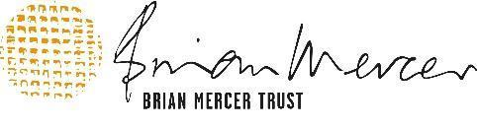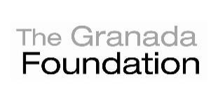

Bluecoat and Castlefield Gallery funders:
