Job application pack for
Office and Facilities Co-ordinator

Thank you for your interest in the vacancy. Please read through the pack and post or email your application to arrive by Sunday 17th July 2016, 5pm.

Applications should consist of:
- A covering letter or statement outlining clearly how you meet the selection criteria in the job description and person specification below
- A current CV that includes the names and contact details of at least two referees, one of whom should be your current or most recent employer.

Please email your application to kwong@castlefieldgallery.co.uk
Or send you applications to Recruitment, Castlefield Gallery, 2 Hewitt Street, Manchester M15 4GB, U.K.

Deadline: Sunday 17th July 2016, 5pm.
Planned interview date: Friday 22nd July 2016.

CG is committed to promoting equal opportunities, and encourages applicants from all sections of the community.

Job Description – Office and Facilities Co-ordinator

Organisation Overview
Castlefield Gallery (CG) is one of Northern England’s most active and successful organisations/agencies for developing emerging contemporary artists and practice. Its ambitious curated exhibitions programme responds to national and international trends, promoting artists at key stages of their careers, including subsequent Turner Prize nominees/winners and exhibitors at international festivals.

Central to CG’s activities is an artist development programme that has launched major commission-winning artists. Castlefield Gallery’s vision is for the North to be a place where artists can live and produce work, while presenting their work in national and international contexts. Its mission is to nurture talent, explore cultural trends and deepen the audience’s relationship to contemporary art.

Job Summary
The role of the Office and Facilities Co-ordinator (OFC) is to ensure the smooth running of core business processes within the gallery. This role has a wide remit covering key office functions including financial management, book keeping, HR administration, supplier management, general office and venue management.

Job Structure

Hours per week: 16 hours per week (can be split into more than 2 regular days)

Rate: £8 per hour

Tenure: Permanent

Reporting Line: Reporting to the Director

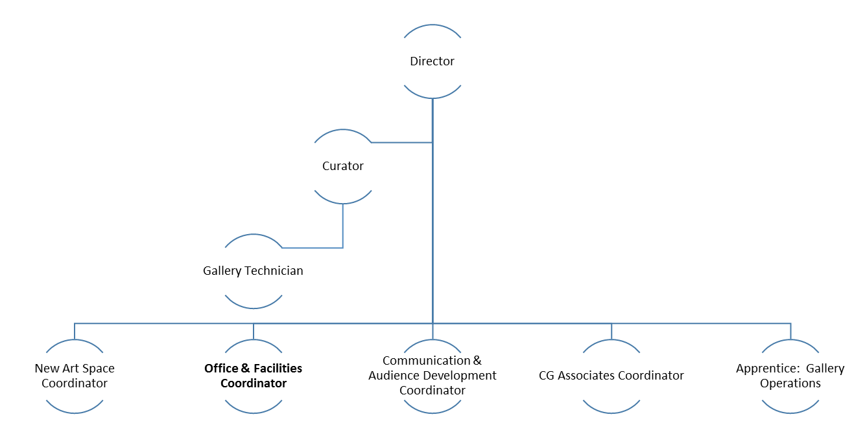

Core Duties

The core duty of the OFC is to support the Gallery Director in the smooth and efficient running of the Gallery operations. This role will be critical in providing administrative support for financial and back office processes. The role will be inclusive of all aspects of office management and provides scope for process improvement and redesign in consultation with the Gallery Director.

The responsibilities for financial reporting will include:

- Utilising QuickBooks for book keeping purposes to ensure the timely logging of financial transactions.

- Ensure payments to suppliers, staff and other payees are made aligned to payment terms.

- Managing incoming payments including invoicing and grants to ensure all monies are logged and accounted for.

- The reconciliation of bank, Paypal and petty cash accounts.

- Taking the lead on VAT returns.

- The preparation of the Cashflow statements.

- Assisting the Director in preparing quarterly management accounts.

- Assisting the Director in preparing annual budgets and accounts.

- Coordinating any other financial activities necessary for the efficient running of the organisation.

The HR responsibilities of the role will include:

- Ensure the staff handbook is updated with relevant information including current programme manual and artist enquiries procedures.

- Facilitation of recruitment and volunteer management including organisation of the volunteers rota.

- Supervision of volunteers during office hours.

- Coordination staff timesheets including the calculation of annual leave accrual.

- Updating and administration of the pension scheme of CG.

The gallery and office maintenance responsibilities of the role include:

- The development of an efficient maintenance schedule to be agreed with the Director.

- Ensuring the premises and the fixtures/fittings (including internal and external gallery signage) are maintained.

- Organising the servicing and repairs of facilities and equipment, including electrical appliances to comply with PAT testing regulations.

- Maintaining equipment, and facilitate their use in accordance with the organisation’s health and safety policy.

- Ensuring IT and communications equipment including telephone, computers, their peripherals and the internet service provision are operational.

- The coordination of effective storage spaces for artwork, fixtures, equipment and tools.

- Fire marshal responsibilities in the event of an evacuation incident, fire or other emergency.

- Schedule and manage regular checks of the fire and intruder alarms, and emergency lights.

- Organising the purchase of cleaning and other products for the upkeep of the premises.

- To be responsible for the maintenance the gallery’s first aid box.

- Updating the incidents record book in a detailed and timely manner.

There are additional organisational and general duties involved in the post which include:
- To be responsible as a key holder for the opening and closing of the gallery, ensuring the security of the gallery and its contents.

- To implement the intruder and fire alarm systems in accordance with the security policy.

- To provide gallery and programme information to the public, artists, partners and suppliers in a manner that represents the organisation, in-person and via mail, email, telephone, or any other communication channels.

- To carry out art and shop sales by cheque, cash and other methods of payment used by the gallery.

- To be responsible for keeping the public, storage and office areas safe, clean and tidy – including a weekly cleaning of the premises.

- To maintain the exhibitions by condition checking on exhibits and implementing opening and closing procedures (e.g. operating lights, computers, projectors etc.) as required.

Person Specification - Office and Facilities Co-ordinator

Essential:

- Computer literacy and confidence - proficient in use of word processing, web browsers and the internet, with knowledge of or willingness and ability to learn and apply other programmes including Quickbooks, databases, spreadsheets, graphics or multimedia packages
- Experience of administering budgets
- Literate and numerate
- Willingness and ability to handle a range of administrative tasks
- Effective communicator in person, on the telephone and in writing
- A motivated, well organised person able to work on your own handling assigned tasks, and to work as part of a team
- Willingness to work on a rota basis to cover weekends, out of hours or additional hours on occasion if required
- Willingness to adhere to all organisational policies including non-smoking, equal opportunities, health and safety

Desirable:

- High level computer skills, experience, and/or qualifications
- Budgeting skills/experience
- Qualifications in health and safety, first aid, or related areas

