Job application pack for Director

Thank you for your interest in the vacancy. Please read through the pack and email or post your application to arrive by Sunday 11 September 2016, 5pm.

Applications should consist of:
- A covering letter or statement outlining clearly how you meet the job description and person specification below.
- A current CV that includes the names and contact details of at least two referees, one of whom should be your current or most recent employer.

Please email your application to recruitment@castlefieldgallery.co.uk
Or send you applications to:

Recruitment
Castlefield Gallery
2 Hewitt Street
Manchester M15 4GB

Deadline: Sunday 11th September 2016, 5pm.
Planned interview date: Monday 19th September 2016

CG is committed to promoting equal opportunities, and encourages applicants from all sections of the community.

Job Description – Director

Castlefield Gallery is seeking to appoint a new Director with the vision to set the agenda for the next chapter of the organisation’s dynamic 32 year history.

Organisation Overview
Founded in 1984, Castlefield Gallery (CG) is one of Northern England’s most active cultural organisations consisting of a leading contemporary art gallery based in Manchester and an agency to support and develop emerging contemporary artists and their practice. Its ambitious curated exhibitions programme reflects national and international trends in contemporary art and promotes artists at key stages of their careers. Past artists include future Turner Prize nominees and winners as well as exhibitors at international art festivals. Central to CG’s activities is its agency, an artist development programme that has launched major commission-winning artists. Strengthening the artistic ecology of the North West is CG Associates, a membership scheme for artists, writers and independent curators providing information, skills, opportunities, resources, promotion and critical dialogue. New Art Spaces provide pop-up project, studio and exhibition spaces for emerging talent.

Castlefield Gallery’s vision is for the North to be the place where artists can live and produce new ambitious work, while presenting their work in national and international contexts. Its mission is to nurture talent, explore cultural trends and deepen the audience’s relationship with contemporary art. Now is an exciting time in CG’s development having just secured ACE’s £150,000 Catalyst Evolve funding to embed sustainability into the organisation over the next three years. This strategic funding is underpinned by revenue support from ACE (NPO) and Manchester City Council (Cultural Partnership). The organisation is a limited company and charity which owns its city centre venue thanks to Arts Council of England’s Capital Lottery funding in 2000.

Job Summary
The Director is responsible for driving forward this next stage of development for Castlefield Gallery. The key functions of the post of Director are to manage the gallery and agency, its staff and programme, and develop, articulate and implement the organisation’s business plan and strategic vision with responsibility for policy, income generation and operations. The Director will work closely with the Board of Trustees, staff and multiple stakeholders to ensure CG’s business plan, strategic goals and targets, including financial targets are met to grow CG’s reach, success and resilience. The Director will work to increase the profile of the organisation in the region and beyond.

Job Structure

Hours per week: 40 hours per week structured to meet the demands of CG

Salary: £27,000 per annum

Reporting Line: Reporting to the Board, with responsibility for all staff

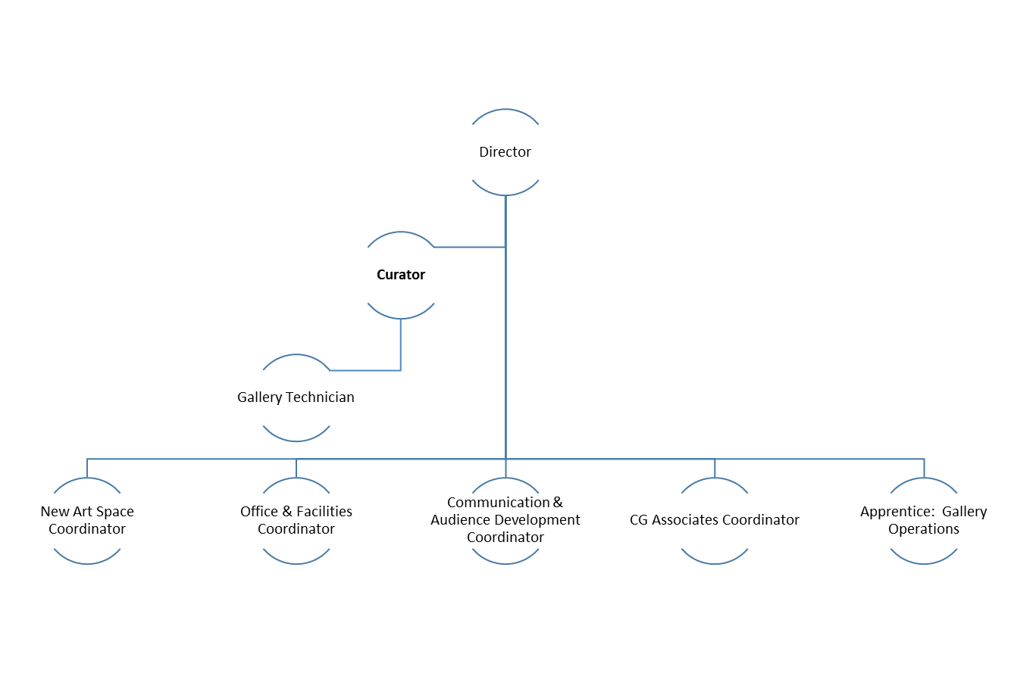

Core Duties and Responsibilities

The key role of Director is to develop and deliver a business strategy for CG that will identify and secure ongoing income streams to enable CG to fully achieve its artistic vision and safeguard its work.

The core duties associated with the role are:

Programme planning and management

- Working with the Board to develop, implement and evaluate a strategic plan to guide the organisation’s artistic programmes and services including artist development, exhibitions, events, the CG Associates Scheme, New Art Spaces, art commissions, consultancy and art sales activities
- Working with the Board and staff to devise and implement the artistic, educational and marketing policies in support of the strategic plan, setting targets for monitoring and evaluation to maintain and improve quality
- Working with the Board and staff to set targets for fundraising, income generation and audience development to support the artistic programme
- Responsibility for developing partnerships and regional, national and international links in the interest of the artistic programme and organisation profile raising
- Responsibility for negotiating and agreeing contracts with artists, funders, business partners, arts organisations, staff, contractors and others

Financial planning and management

- Working with the Board and staff to prepare and manage effective financial administration, comprehensive budgets and cash flow reports
- Working with the Board and staff to maintain internal finance control systems that ensure sound bookkeeping and accounting procedures are followed in compliance with funding and statutory requirements
- Administering the funds of the organisation according to the approved budget and monitoring the monthly cash flow
- Approving expenditures within the authority delegated by the Board
- Providing the Board and Funders with comprehensive and regular reports on the revenues and expenditure of the organisation
- Ensuring that the organisation complies with all financial legislation and reporting requirements of funders, Companies House, HM Revenue & Customs, the Charity Commission and all other relevant bodies
- Overseeing the development and implementation of the fundraising plan
- Working with the Board and staff to research, develop and secure new income sources including trusts, foundations and business sponsorship. The post holder is required to be proactive in this activity and to seek out new opportunities

Operational planning and management

- Developing an operational plan which incorporates goals and objectives towards the strategic direction of the organisation
- Preparing procedures to implement the organisational policies and reviewing policies on an annual basis to maintain excellent management systems that comply with relevant legal and administrative requirements including company and employment laws, and regulations governing tax, VAT, charities, health and safety, equal opportunities, diversity, data protection and intellectual property
- Ensuring the operation of the organisation meets the expectations of stakeholders including artists, public, Board and funders
- Overseeing the effective and efficient day-to-day running of the gallery
- Fulfilling the role of Company Secretary with responsibility for the management of Board meetings and the AGM as well as ongoing communications with the Board, compliance with company and charity laws and all associated administration
- To nominate and brief a Deputy in the event of absence

Human resources planning and management

- Overseeing the human resources policies, procedures and practices including the staff handbook and job descriptions for all staff
- Responsibility for the employment and management of all staff, volunteers and trainees including recruitment, contracts, payroll, performance, attendance, timesheets and rotas
- Managing the ongoing development of the organisation through staff training, board development, and volunteer programmes
- Establish a positive, healthy and safe work environment in accordance with all appropriate legislation and regulations
- Monitor the performance of staff on an ongoing basis and conduct an annual performance review
- Coach and mentor staff as appropriate to improve performance

Advocacy

- Develop and maintain relationships with important stakeholders including the local authorities, the Arts Council England and other funders, sponsors and HE and FE institutions, keeping them informed of and helping them engage with the work of the organisation
- Establish good working relationships with the artistic community served by the organisation including artists, collectors, curators and artist-led groups to help achieve the goals of the organisation
- Develop relationships through special projects with collectors and commissioners of artwork and artists
- Develop strategies and targets for the marketing and promotion of the gallery and agency including the development of new audiences through special projects and initiatives
- Act as a spokesperson for the organisation to enhance its profile and reputation

The Director will be expected to undertake additional tasks if required for the operational and strategic sustainability of the organisation.

Person Specification:

Essential
- Five or more years of experience managing a similar organisation or project management
- Experience of managing staff and budgets
- Experience of fundraising including grant applications and sponsorship
- Experience of income generation
- Deep understanding of contemporary art practice both within the UK and internationally
- Proficient IT skills
- Effective communication skills
- Flexibility in a varied work environment and the ability to maintain positive working relationships, both internally and externally, to achieve the aims of the organisation
- Demonstrate a commitment to equal opportunities

Desirable
- University degree in a related field
- Experience of supporting talent development
- Experience of working with a Board

